Dell Controlled Print

Specification

Service DPK Utility
User Guide
Installation / Integration

Specification Number: ENG0020088
Revision: A20

Oct/13/2026

Author: Roni Karmineke
Owner: GSP Engineering & Quality

PROPRIETARY NOTE
This item is the property of Dell Inc., Round Rock, Texas and contains confidential and trade secret information. This item may not be transferred from the custody of Dell Inc., except as authorized by Dell Inc. and then only by way of loan for limited purposes. It must not be reproduced in whole or in part and must be returned to Dell Inc. upon request and in all events upon completion of the purpose of the loan. Neither this item nor the information it contains may be used by or disclosed to persons not having a need for such use or disclosure consistent with the purpose to the loan without prior written consent of Dell Inc.

Table of contents
Table of contents 2
Revision History 4
1) VISIO Flows 10
1.1) High Level Communication Flow 10
1.2) DPK Tool Flow 10
2) Information 11
2.1) Requirements 11
2.2) Available Command Lines 11
3) Windows Server Setup 12
3.1) Install .NET 3.51 w/sp1 12
3.2) Windows Update 13
3.3) Windows Server – Add these directories to your server 13
3.4) Windows Server - Configure Windows Firewall to allow inbound TCP 1433 14
3.5) SQL Server Express and Server Windows Update guidance 18
3.6) SQL Server 2014 Express – Installation and Upgrade Instructions 18
3.7) SQL Server 2014 Express - Configuration 23
3.8) Create the SQL User for the DPK Injection process 25
3.9) Option to use SQL Server Express 2019 28
3.10) SQL Server 2019 Express - Configuration 40
3.11) SQL Server 2019 Management Studio – Create the SQL User for the DPK Injection process 42
4) Configuring DPK Tool for your location 44
5) Create the DPK Database and Import/Export DPKs 45
5.1) SQL Server connection test 45
5.2) Database creation 45
5.3) DPK Import to database from csv file 45
5.4) DPK Export from database to a csv file to reclaim DPKs 45
5.5) Put a DPK on standby to Rework an MBD 46
5.6) Reuse a DPK that has a status of in use for a set number of days 46
5.7) Query the database for a count of available DPKS 46
6) Auto Pilot Deregistration 46
6.1) Modify the DPK Database to add Auto Pilot Deregistration for existing versions before moving to 1.0.0.64 46
6.2) Auto Pilot Logging 47
7) ARM64 Support for DPK Injection 47
7.1) Windows Requirements 47
7.2) WinPE Requirements if running under WinPE 48
7.3) Files added for ARM support 48
7.4) Tools Requirements for ARM 49
7.5) Change needed for the SDS_DPK.ini 49
8) Windows 11 OS configuration 49
9) Executing the DPK Tool 51
9.1) Flash / Inject new DPK 51
9.2) DPK Tool Error Codes 51
9.3) Input Requirements 52
9.4) Script Integration 53
9.5) Script Update for Verify Stability 54
10) Database Structure 57
10.1) DPK Table Fields and Data Types 57
11) Recommendations 57
11.1) Backup Strategy 57
12) Appendix 58
12.1) SDS_DPK.ini 58
12.2) Verifying SQL Server Configuration 59
12.3) DPKDB Database backup and restore. Synchronizing ImportUser SID between servers 62
12.4) SMBIOS used to determine which IBV tool to use to inject DPK. 79
12.5) Script Integration-Stand Alone Instructions 80
12.6) Script Integration Example 80
12.7) Using SDS_DPK_x64.exe in WINPE only 81

Revision History

Rev. | PCO # | Revision Description | Approved By | Date | TDC | Date
X01 | N/A | Initial Draft | Roni Karmineke (Soft Thinks ) | 05/31/19
X02 | N/A | Updated PC DCTR Test Section | Roni Karmineke (Soft Thinks ) | 05/31/19
X03 | N/A | Updated to add new features 1.0.0.16 | Roni Karmineke (Soft Thinks ) | 06/06/19
X04 | N/A | Changed version number, added script sample | Roni Karmineke (Soft Thinks ) | 06/07/19
X05 | N/A | Updated new features for 1.0.0.22 and added process flow change (see script integration) | Roni Karmineke (Soft Thinks ) | 06/12/19
X06 | N/A | - Added Winpe section for Version 1.0.0.24 and backup strategy.  - Updated example script error handling.  Initial release in Agile | Roni Karmineke (Soft Thinks ) | 06/28/19
X-Rev | PCO42532 | Initial Release ENG0020088 X-rev | Blake Melancon | 06/28/19 | Frank Barajas | 06/28/19
A00 | PCO42549 | Initial Release of ENG0020088 to Rev A00 | Blake Melancon | 07/01/19 | Frank Barajas | 07/01/19
A01 | PCO43245 | ENG0020088 to Rev A01  Added additional logging and error handling for Phoenix Bios | Ayub Shafi | 10/04/19 | Frank Barajas | 10/04/19
A02 | PCO46311 | ENG0020088 to Rev A01  Added new commands, page 7  Added RECLAIM and REUSE page 31, 32  Added new error codes, page 33  Replaced default SDS_DPK.ini, page 32  Replaced Desktop script, page 43 | Ayub Shafi | 11/8/2019 | Frank Barajas | 11/08/19
A03 | PCO44066 | Added Code update for Verify stability  Page 37 | Ayub Shafi | 01/29/2020 | Frank Barajas | 01/29/23
A04 | PCO45101 | Added New Encryption method.  Added Rework Process Command PG 7  Added EOL/Purge process PG 7  Add new error codes PG 34  Add Encryption to EOL/Purge process  Add fix to Microsoft Encrypt process seen on some OS/hardware combinations | Ayub Shafi | 04/30/2020 | Frank Barajas | 04/30/23
A05 | PCO4611 | Release version 1.0.0.44  New Insyde BIOS Tool and better logging of UUT configuration | Ayub Shafi | 10/09/2020 | Frank Barajas | 10/09/23
A06 | PCO046246 | Release version 1.0.0.45  New Dell OA3 tool compiled. | Ayub Shafi | 12/01/2020 | Frank Barajas | 12/01/20
A07 | PCO46416 | Release version 1.0.0.47  Workaround to use the previous DellOA3 tool if the new DellOA3 tool throws delloa64.exe, error code = 255.  Removed the limitation of database management that is locked to Dell/Alienware systems PG 35 | Ayub Shafi | 01/22/2021 | Frank Barajas | 01/22/21
A08 | PCO47749 | Release Version 1.0.0.50  Add New OA3 Tool as required from Microsoft.  Change: add detecting execution under Winpe. If dpkppid_filePath was setup to save to C:\OA30\DPK\dpkppid.txt it will be changed on the fly to X:\OA30\DPK\dpkppid.txt(pg 54)  Add instructions on how to upgrade SQL (pg 33)  We added a new AMI Bios tool needed for newer platforms that we will switch to automatically if the current AMI Bios tool fails (pg 57) | Ayubi Shafi | 8/16/2021 | Frank Barajas | 08/16/21
A09 | PCO47938 | Added Clarification to SQL version requirements and adding Install instructions for SQL Express 2019  (Pg 34)  Added Windows Update and SQL Express Service Pack installation guidelines (Pg 19) | Ayub Shafit | 10/13/21 | Frank Barajas | 10/13/21
A10 | PCO48645 | Release Version 1.0.0.54  Enable Decryption with new key change to 358 characters.  Added logging oa3tool.exe version.  When corrupted DPK entry found (status = 8) log entry and data received from sql directly to document communication issues.  Add security around setting dpk to corrupted status to avoid purging all dpks.  DPK ini setting: [Options] Corrupted_DPK_attempts=3 -> by default if not set  (pg | Ayub Shafi | 03/22/22 | Frank Barajas | 003/22/22
A11 | PCO48820 | -Changed the file copy API used when creating the local DPK injection working directory.  Depending upon the locations network architecture, a delay in the file copy process could be introduced, causing the DPK injection time to be increased. | Ayub Shafi | 04/20/2022 | Frank Barajas | 04/25/22
A12 | PCO48883 | Release version 1.0.0.56  Change to the Insyde Bios tool. From 1.1.0.0 to 1.2.0.0 .  If the version 1.2.0.0 fails it will fail over to using the version 1.1.0.0.  If a runtime error is seen during the injection process, please ensure that the date is set correctly UUT. | Ayub Shafi | 05/09/2022 | Frank Barajas | 05/09/22
A13 | PCO49805 | Release version 1.0.0.64  Change to add Autopilot deregistration. This requires a database update adding two new fields to capture the AutoPilot information. Please See Section 6 titled Auto Pilot Deregistration on Page 65 & 64 before moving to 1.0.0.64 or higher. | Mike Barr | 09/23/2022 | Frank Barajas | 09/27/22
A14 | PCO50391 | Release version 1.0.0.68  Change to add support for QUALCOMM ARM64.  PG66  Release Version 1.0.0.68  Added AMI BIOS tool v1.5.04 for D13 AMD Raphael system Alienware Aurora R15 AMD, 1.0.0.  Tool will switch automatically if the current AMI Bios tool fails.  Added Support in WinPE for older WinPE Version used by Compal.  Added documentation about Windows 11 OS feature that will make DPK and other Dell tools not run with recent security update from Microsoft  Pg 68 | Vivi Ma | 01/10/2023 | Frank Barajas | 02/05/23
A15 | PCO50502 | Added new Insyde bios tool version 1.2.1. for platforms axiom_15_rmb, axiom_17_rmb, sif_mlk_rmb. SDS_DPK will use the new version first, if it fails, then it will use the prior versions, 1.2.0.0 and 1.1.0.0 for backward compatibility. | Vivi Ma | 01/25/2023 | Frank Barajas | 03/01/23
A16 | PCO52269 | Version 1.0.0.71  Replaced DPK_TOOLS\AMI3 folder content with AMI BIOS Tool Version 5.05 from the prior version 5.04 to support new AMI BIOS release  Alienware, Alienware Aurora R15 Intel Platform - BIOS: 1.5.0 07/05/2023 | Vivi Ma | 11/08/2023 | Frank Barajas | 11/17/23
A17 | PCO53155 | Release version 1.0.0.73  Change to add support for new QUALCOMM ARM64 platforms.  Update: ARM tool QCfactory upgraded to 1.0.3963.8500  Supported platforms  WARLOCK_NQ_14 (Inspiron 14 3420 Shipping)  THENA_NQ14_7441  (not shipping yet)  THENA_NQ14_5441 (not shipping yet)  TRIBUTO_QC XPS 13 9345  (not shipping yet)  THENA_14_QC_L_5455  (not shipping yet)  THENA_14_QC_L_PREMIUM_7455 (not shipping yet) | Vivi Ma | 05/20/24 | Frank Barajas | 05/31/24
A18 | PCO53310 | New ECO 49125C to release the DPK D4RWD SWB, SW DPK (SDS DPK 1.0.0.73) | Vivi Ma | 06/13/24 | Frank Barajas | 06/13/24
A19 | PCO53708 | New ECO 49125C to release the DPK H5DD2 SWB, SW DPK (SDS DPK 1.0.0.76) | Vivi Ma | 08/13/24 | Frank Barajas | 08/21/24
A20 | PCO58140 | Update the DPK tool version to 1.0.079 and review the overall document formatting. | Carlos Madureira | 10/13/26 | Frank Barajas | 10/13/26

VISIO Flows

High Level Communication Flow

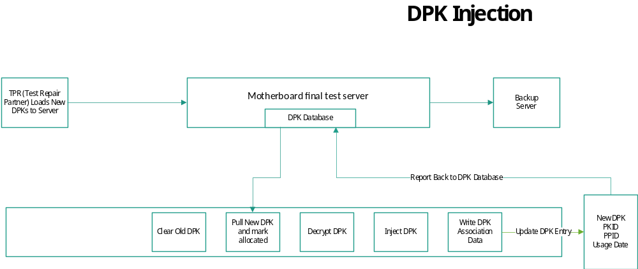

DPK Tool Flow

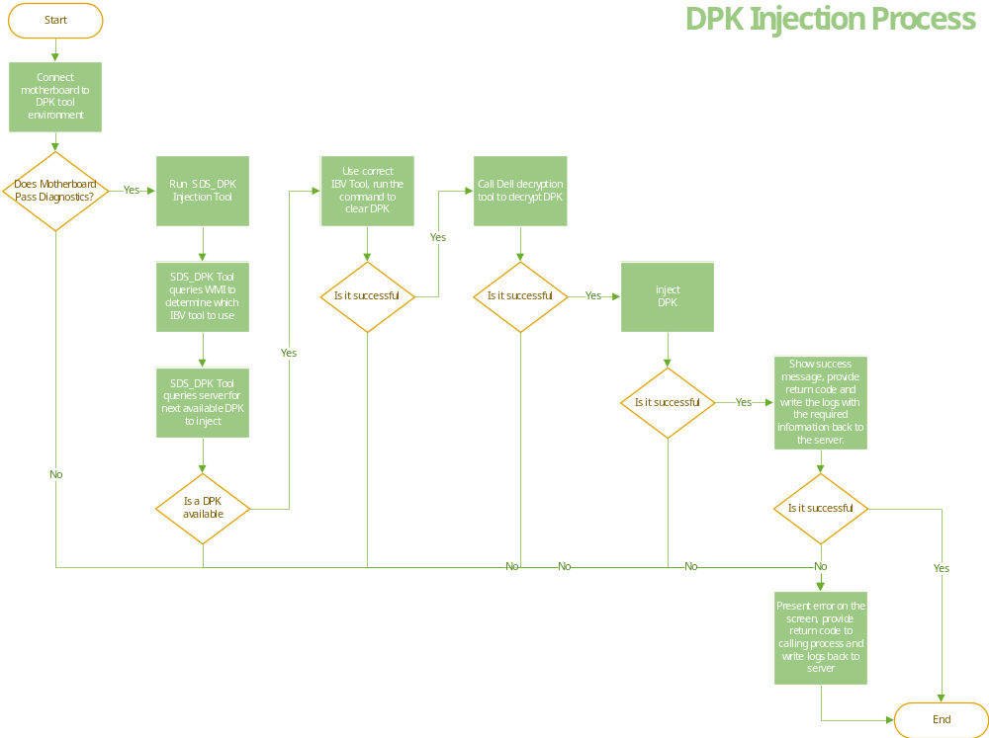

Information

Requirements

Server | Server OS | Server 2012 R2 or greater. Recommend to check the Windows Server Lifecycle for best version to use.
 | .NET 3.51 w/sp1 | Native to Server 2010 or higher
 | Windows Updates | Server OS updated to latest Windows Updates
 | SQL Server 2014 | Provided with Installation Deliverables
 | Open Port for SQL | Default is 1433
 | Add Directory | \TFTPRoot\DPK
 | Add Directory | \TFTPRoot\DPK_Logs
 | dpkppid.txt file | Input file created or scanned from the MBD or Traveler
Client | Windows 10 | .NET 4.5 is needed to run on the UUT / Client. If it’s an older OS than Windows 8 will need to be installed.
Client ARM64 | Windows 11 | Version 10.0.22.621.674
Client ARM64 | Windows 11 Winpe | Version 10.0.22.621.4  Realtek Driver For the USB Dongle

Available Command Lines

Command Line | Description
SDS_DPK.exe /SET_PASSWORD:”Import123!@#” (or the password for sql account if different) | Sets the password in the SDS_DPK.ini if changed from default
SDS_DPK.exe /TEST_CONNECT | tests the Database Connection
SDS_DPK.exe /INSTALL_TABLE | Creates the database
SDS_DPK.exe /IMPORT:”c:\temp\dell_dpk.csv” | Imports the available DPKs. Need to define the location of the CSV
SDS_DPK.exe /AUTO /PN:"DELL" | Will inject a Dell DPK
SDS_DPK.exe /AUTO /PN:" WYSE" | Will inject a WYSE DPK
SDS_DPK.exe /ERASE | Clears DPK only, switch is exclusive and cannot be used with any other
SDS_DPK.exe /VERIFY | Verifies DPK is a 5 by 5, switch is exclusive and cannot be used with any other
SDS_DPK.exe /RECLAIM:50,”DPKExport1.csv | Example needs number and file name passed(run only as needed, DB Admin)
SDS_DPK.exe /RECOVER_INUSE | Recovers status 3 (run only as needed, DB Admin)
SDS_Dpk.exe /RECOVER_EOL | Records current motherboard DPK to the SQL server.  DPKID/DPK are added  Sets the Facility field to <EOL>  Sets the status = 1  Erases the DPK from the local motherboard.  If entry already exists with status = 7, Status for entry is set to 128 to avoid it being reused but allows for tracking.
SDS_Dpk.exe /STANDBY_REWORK | Saves the current motherboard DPK to the SQL Database, then erases the local DPK. When the command is run it will mark the current computer DPK if it exists in the database status is set = 64 and set the Facility field to <Rework>. If the DPKID PPID does not exist in the database, a new entry will be added with status = 64 and Facility = <Rework>. When the /Auto switch is used again on same computer (PPID) then the same DPK will be reused.

Windows Server Setup

Important: Windows Server - 2012 R2 Setup Guide, must be Server 2012 R2 or greater

  - Install .NET 3.51 w/sp1
  - Enable this by going to Server Manager
  - Select Features
  - Add Features
  - Select .NET 3.5.1 to install
**Note: If you have a newer version of Server OS, this may be already enabled
Once installed the Features screen will look like this.

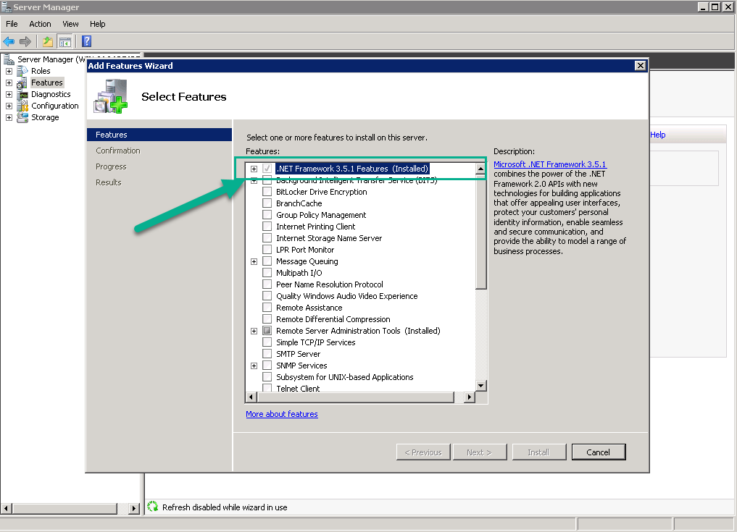

  - Windows Update
Run Windows Update to get the latest updates for the server OS.

  - Windows Server – Add these directories to your server
Create the following directories on the Server

- \TFTPRoot\DPK
Copy the SDS _DPK executable and tools directory to the DPK directory as shown below.

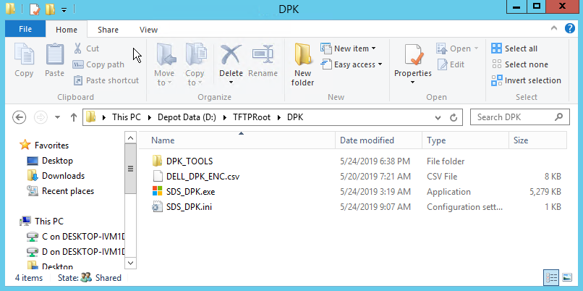

- \TFTPRoot\DPK_Logs
This directory will be used to store the log files. – it will be blank until you process some systems.

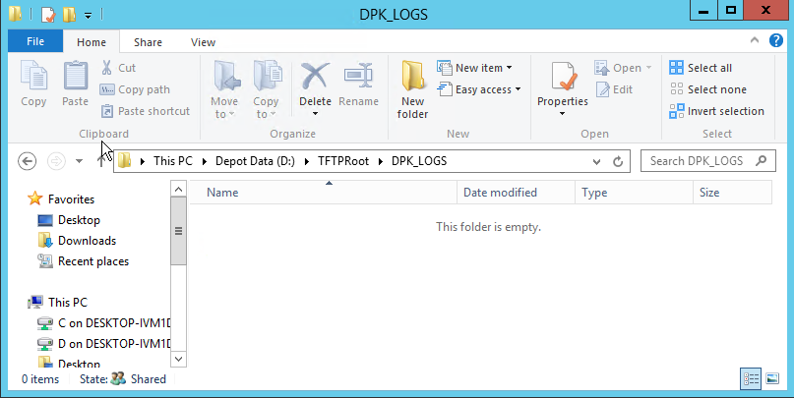

  - Windows Server - Configure Windows Firewall to allow inbound TCP 1433
Open TCP port 1433 on Windows Firewall.
Right click on the network icon in the lower right-hand side of the screen.


Click Open Network and Sharing Center
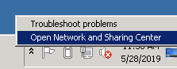

Click on Windows Firewall
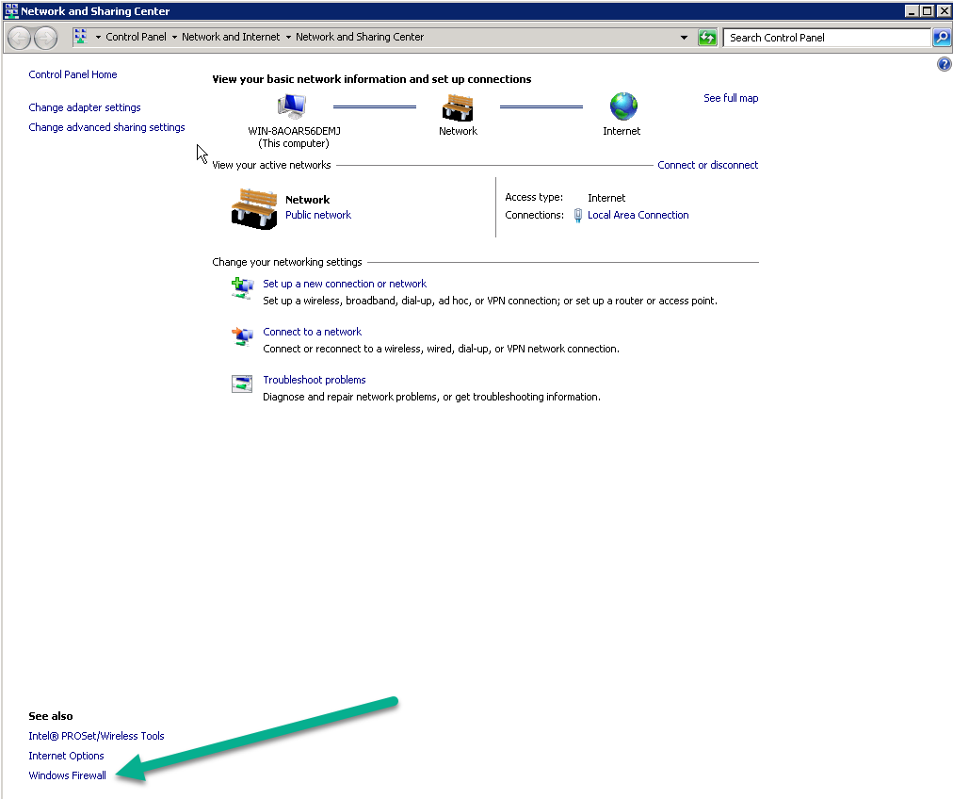

Click on Advanced Settings
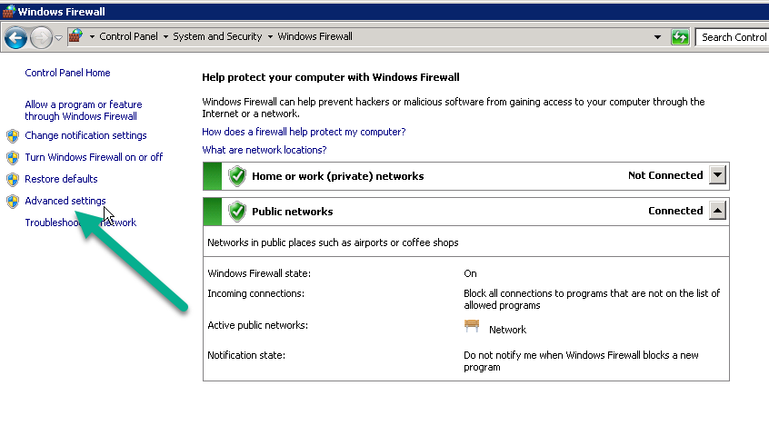
Click on Inbound Rules. Then click on New Rule
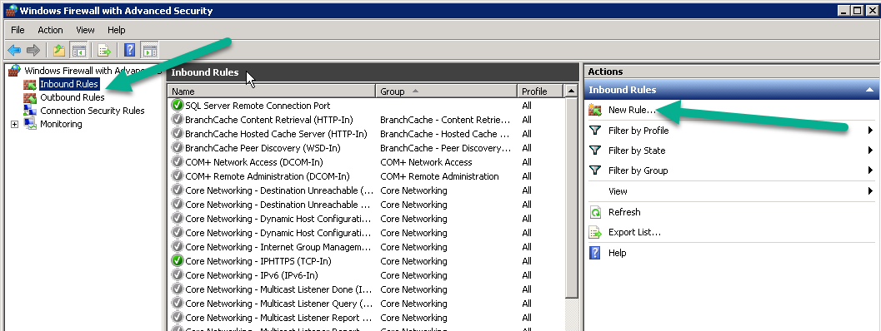

Select Port and click on “Next”
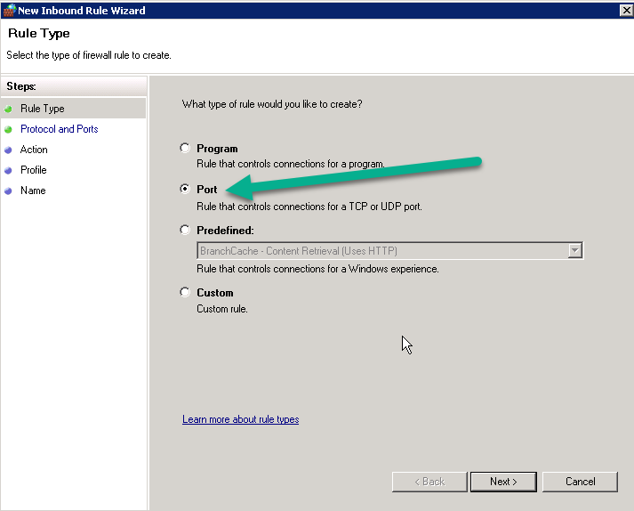

Type in port 1433 and click on “Next”
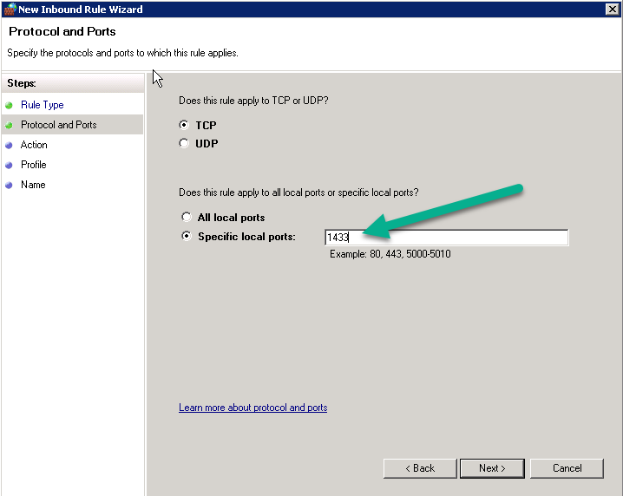

Leave Allow the connection selected and click “Next”
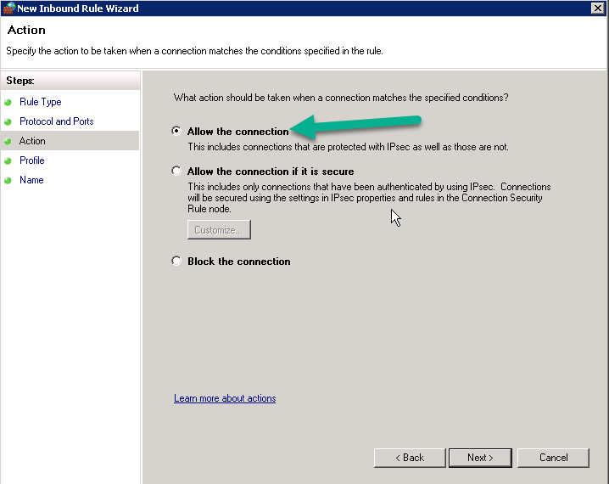

Check Domain and Private and uncheck Public and click “Next”
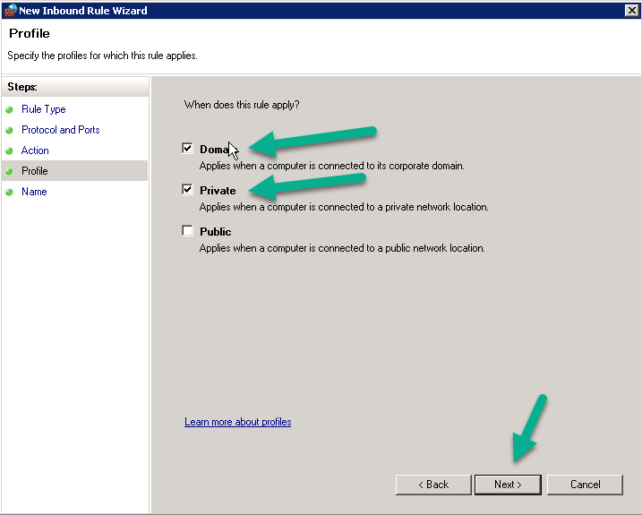

Type in SQL Server TCP/IP Port 1433 for the name and description for identification later if needed
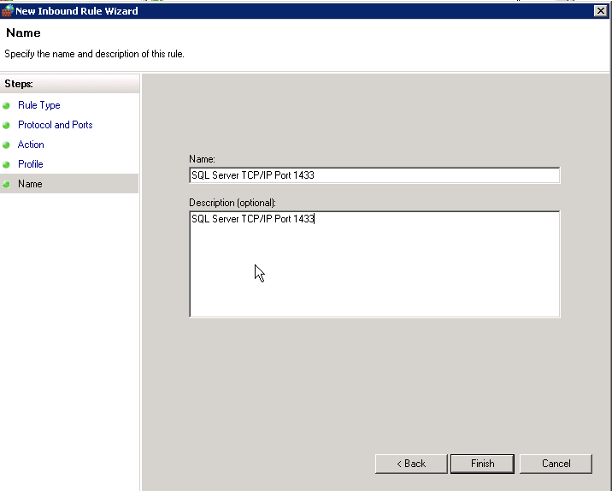

Verify the Rule is enabled by looking in the enabled column.
Close Windows Firewall.

  - SQL Server Express and Server Windows Update guidance
Windows Updates and SQL Express Service Pack installations should be done per your IT department’s guidelines and follow the SOP given.
We recommend that before installing any SQL Service Pack that your database is backed up.
These updates should be performed while systems are not processing.

  - SQL Server 2014 Express – Installation and Upgrade Instructions
Extract SQLEXPRADV_x64_ENU.zip and run the SQLEXPRADV_x64_ENU.exe provided in the deliverables package to extract the installation folder and start the setup process.

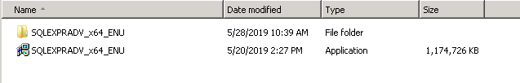

The SQLEXPRADV_x64_ENU directory will be created next to the SQLEXPRADV_x64_ENU.exe file and then the setup program will start automatically.
Click on the link “New SQL Server Stand-alone installation or add features to an existing installation”

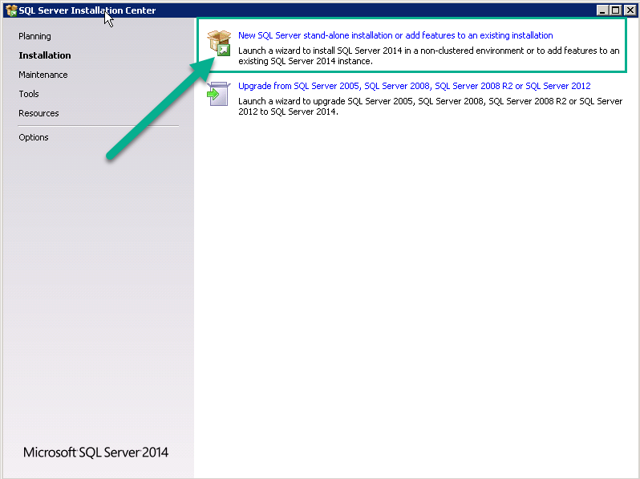
Check the license agreement and click “Next”
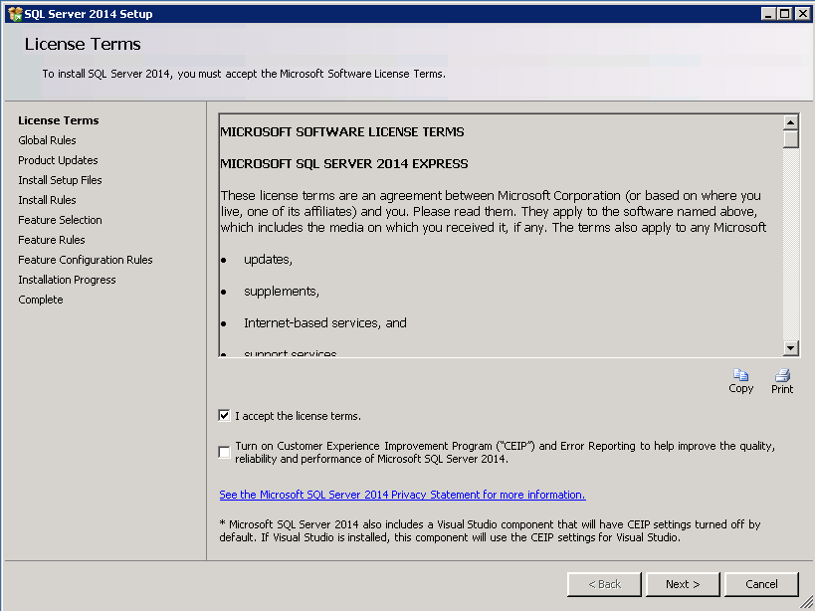
Setup will check for updates
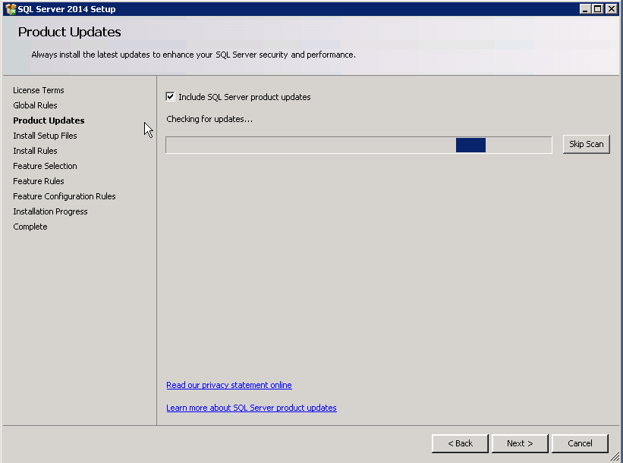
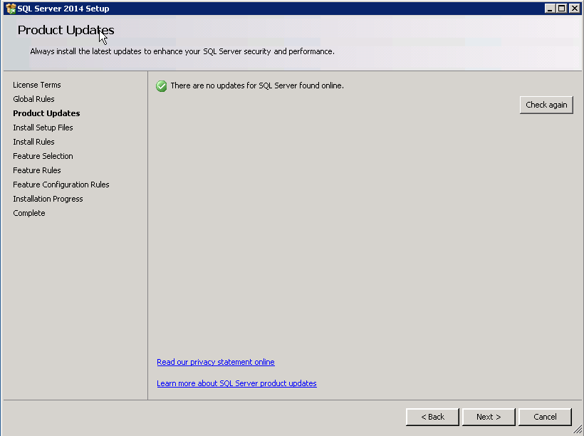

Select only the items shown below in screenshot and click on “Next”
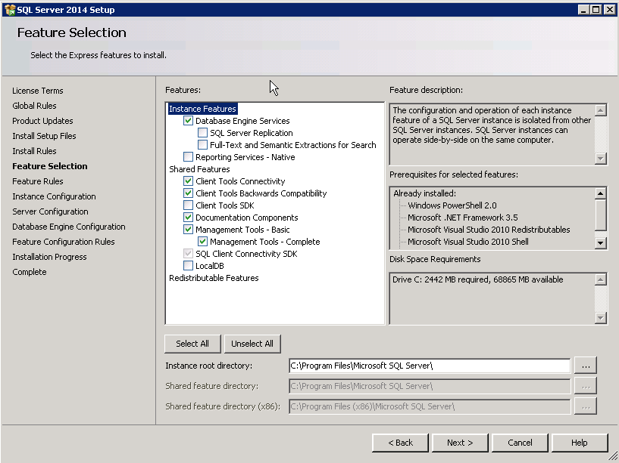

Select the Default Instance instead of the SQLEXPRESS instance and click on “Next”
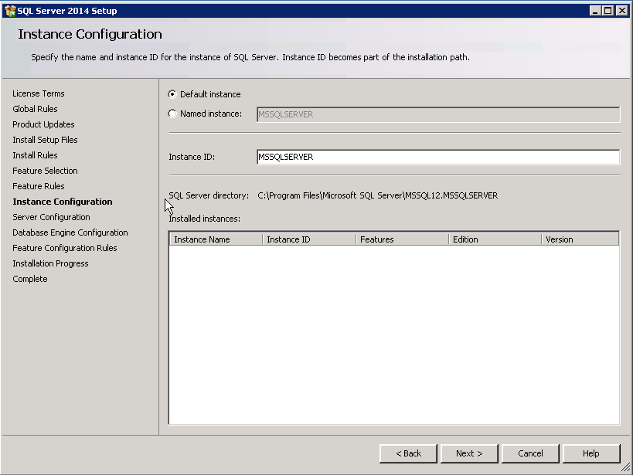

Once the below screen appears, keep the defaults and click on “Next”
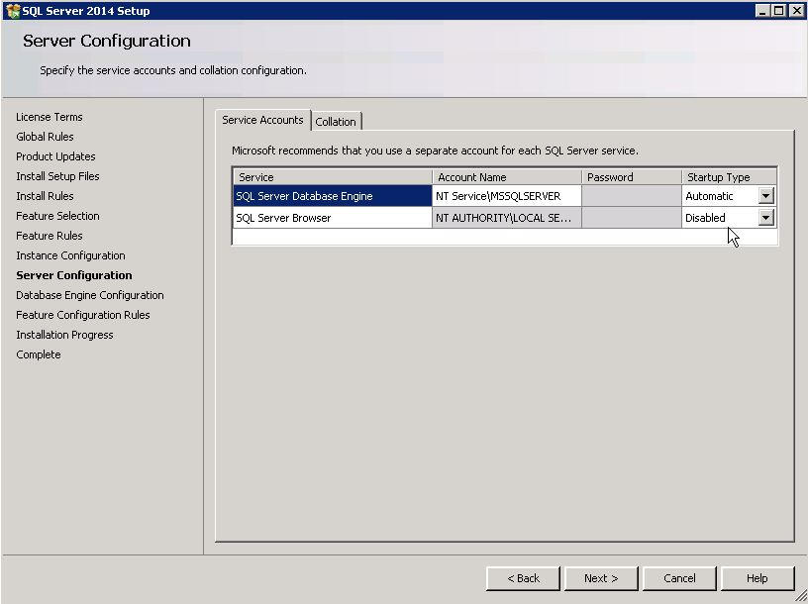
Select Mixed Mode and type in a password “OSAdmin123!@#” and click on “Next”

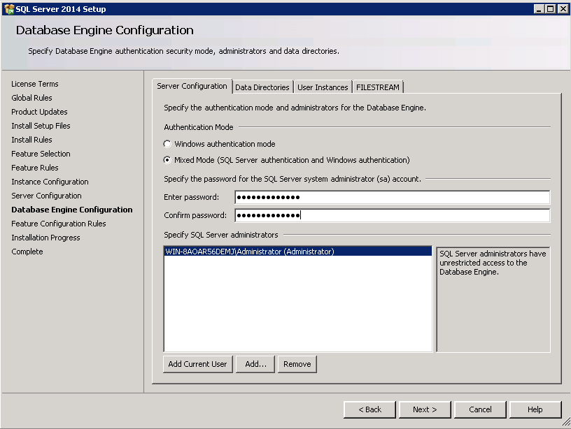

Installation will start showing progress as shown below.
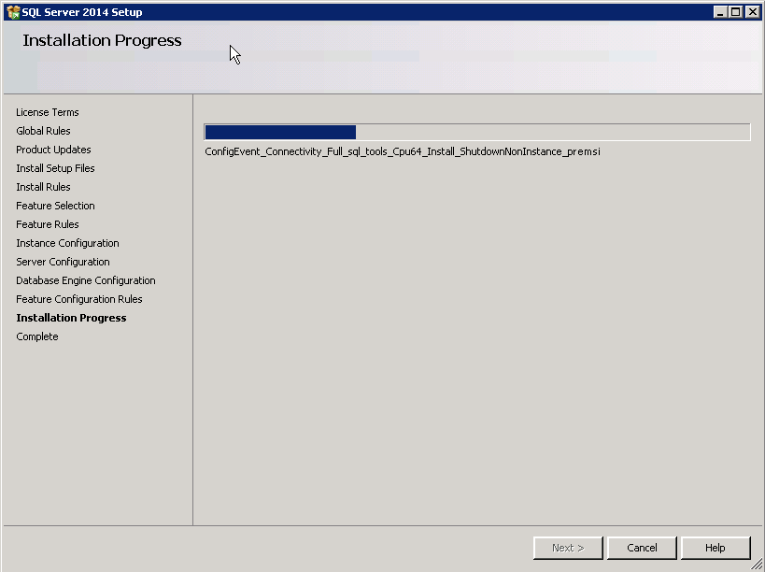
Once setup is complete, you will see the below screen - click “Close”
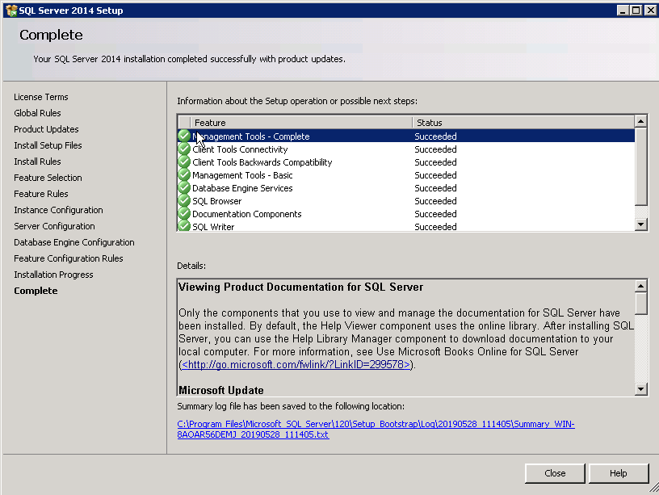
Close the main setup screen.

  - SQL Server 2014 Express - Configuration
Open SQL Server 2014 Configuration Manager under:
Microsoft SQL Server 2014 Configuration Tools SQL Server 2014 Configuration Manager.
Select SQL Server Network Configuration and click on Protocols for MSSQLSERVER
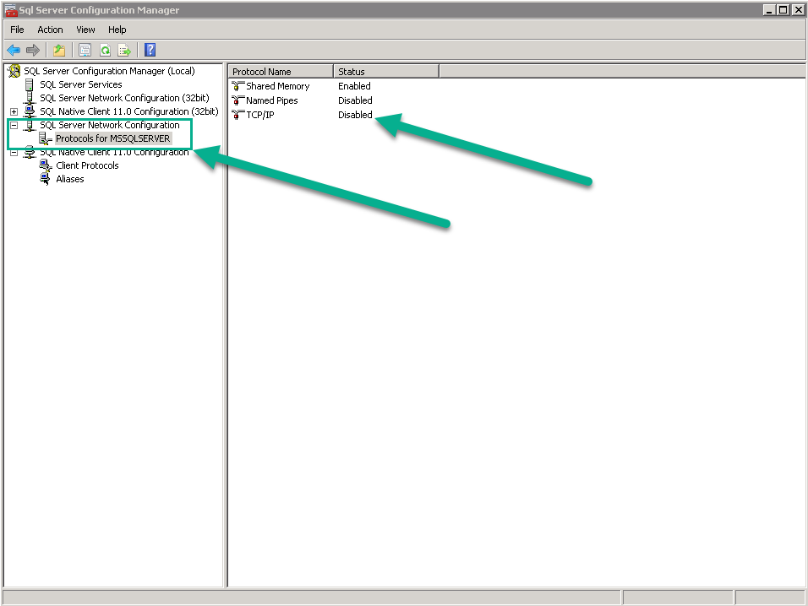

Double click on TCP/IP and change to Yes

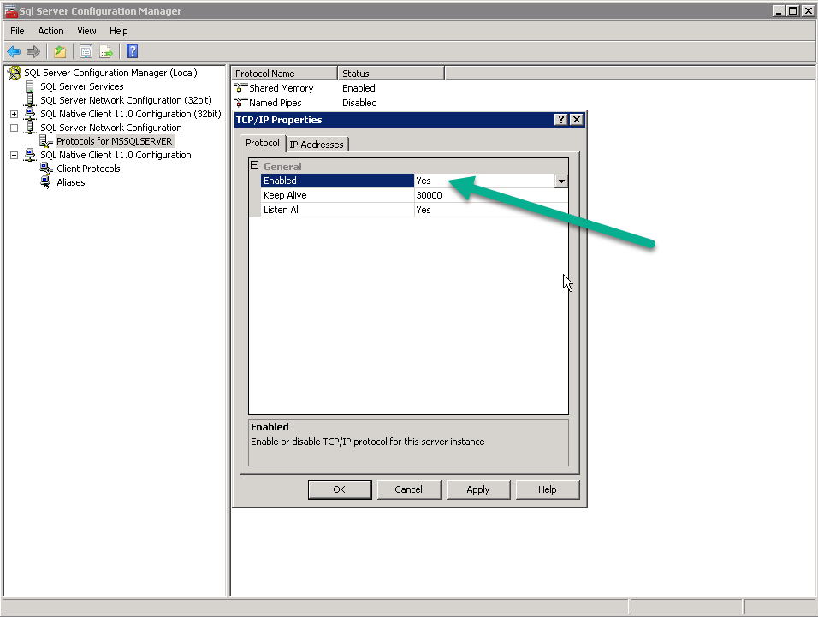

Restart SQL Server by click on SQL Server Service. Then on the right side of the screen right-click on SQL Server (MSSQLSERVER) and click on Restart to apply the change.

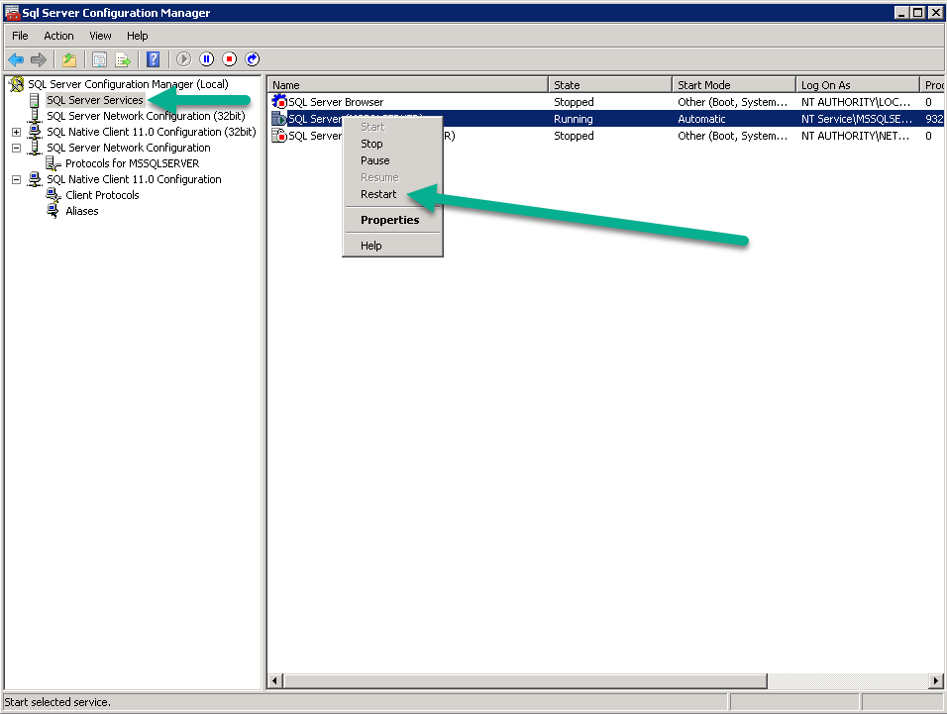

Close SQL Configuration Manager

  - Create the SQL User for the DPK Injection process
Open SQL Management Studio.

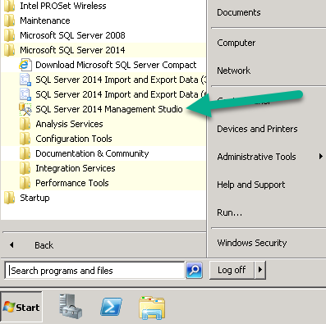
  - Notes:
    - if you get an error, we had to run the .NET repair tool.
    - You can also run the setup and select maintenance to fix issues.

Open SQL Management Studio and connect to the SQL Instance. Use “Windows Authentication”

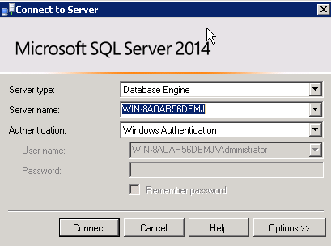

Click on Security then Login. Right click and select New User.
Important Note: Make sure Enforce password policy is not checked, as well as Enforce password expiration and User must change password on next login which shows grayed out in this example.

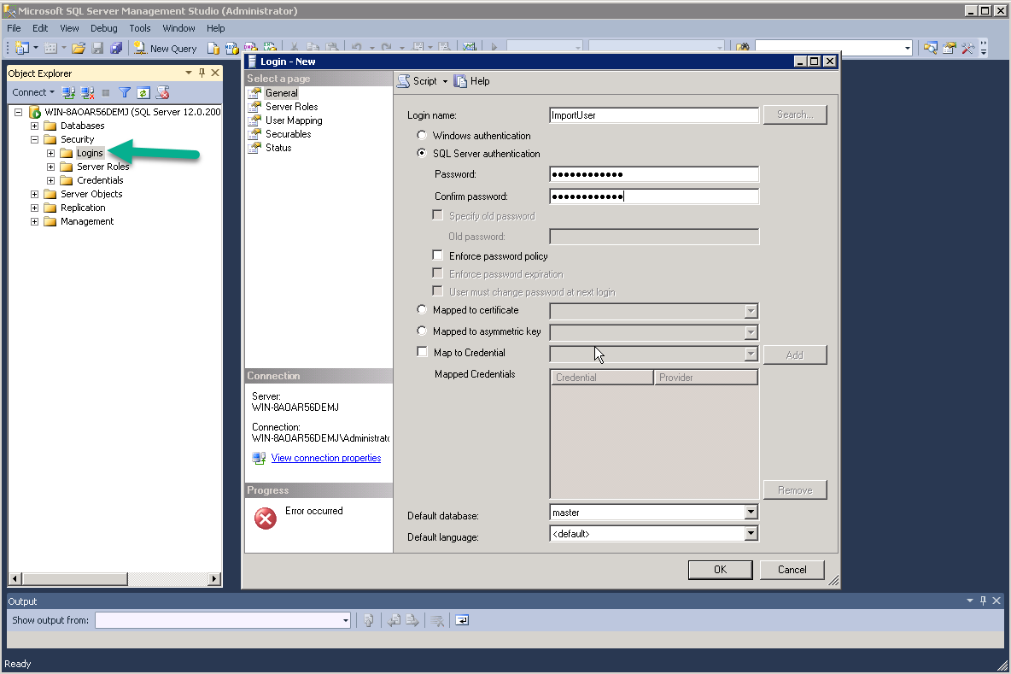
Type in the username and password to be used for the database.
User: ImportUser
Password: Import123!@#
Note: if you change this password from the one above you will need to run the command below to set the correct encrypted password in the SDS_DPK.ini.

Adding the SQL account password to the SDS_DPK.ini
To set the password in the SDS_DPK.ini you will need to run this command. This command will encrypt the password and update the INI file with the password.
C:\>SDS_DPK.exe /SET_PASSWORD:”Import123!@#” (or the password for sql account if different)

Click on “OK”
Once the user is added – double click on it and give it just 2 permissions: Connect SQL and Create any Database
Important Note: DO NOT USE ADMIN credentials for this account for the best security.
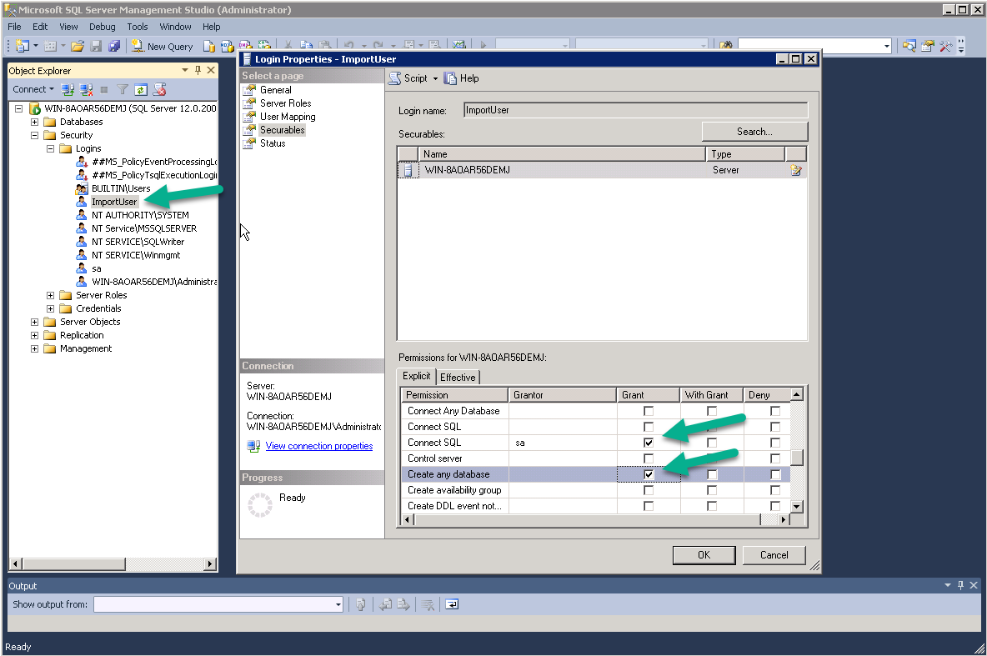
The new SQL account that you just created will be used to do the following:
  - Create the Database on first use.
  - Create the table with Fields and Datatypes

  - Option to use SQL Server Express 2019
This is not required but documentation is being provided for TPRs setting up for the first time or upgrading their server hardware or Operating System.

Download SQL Server Express 2019 from the below Microsoft website.

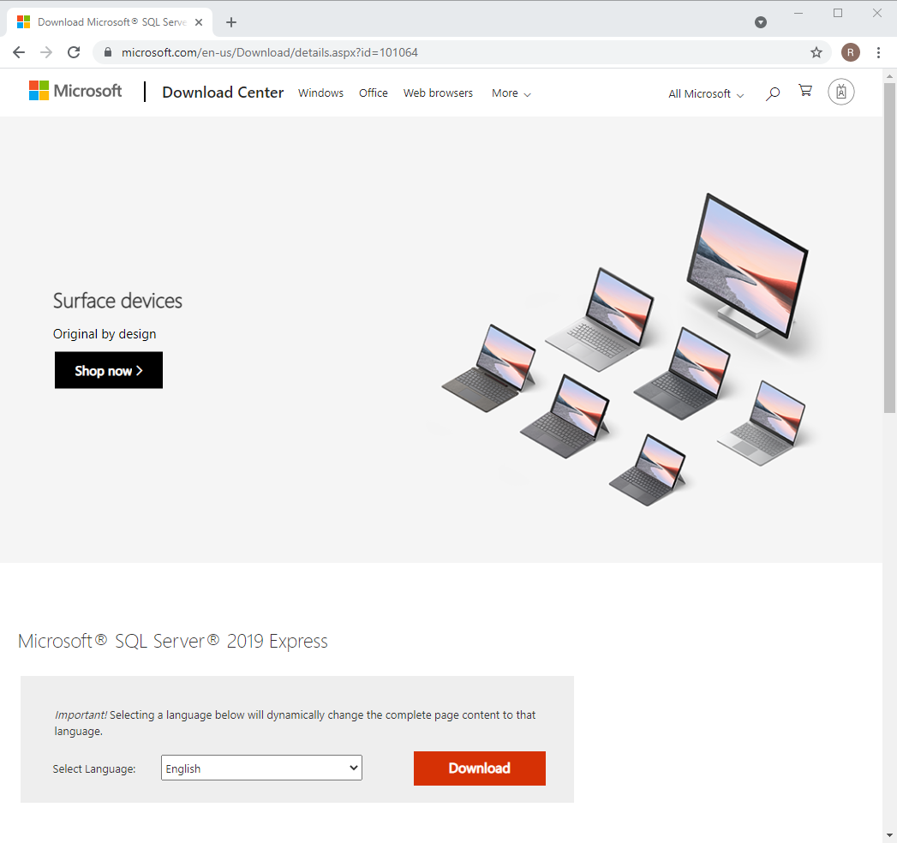
The file named SQL2019-SSEI-Expr.exe will be downloaded.

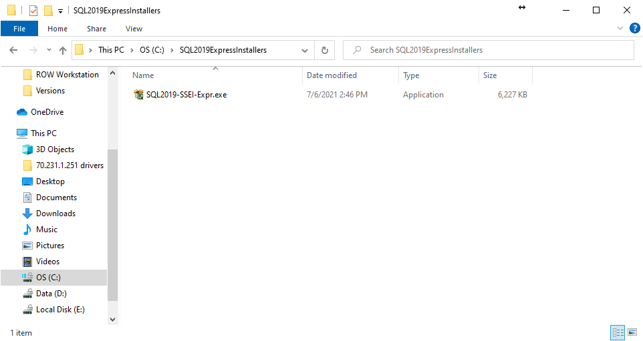

Double click on the SQL2019-SSEI-Expr.exe and “click” on the “Download Media” button as shown below.

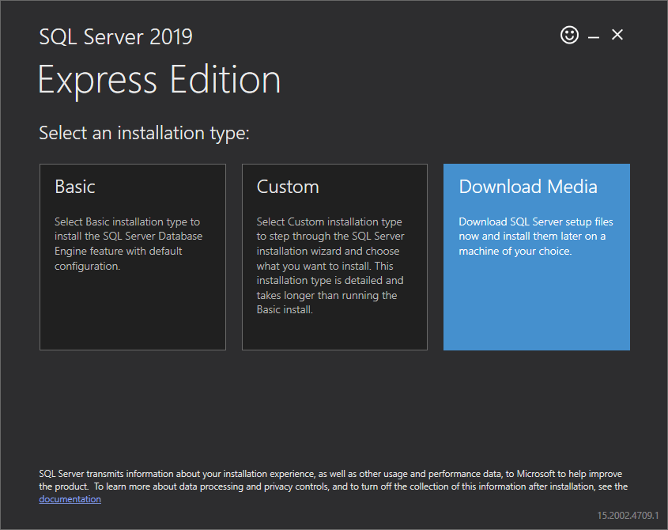

Select the following items
- The “Language”
- The Package “Express Advanced (796MB)”
- The location
  - Ex… C:\SQL2019ExpressInstallers

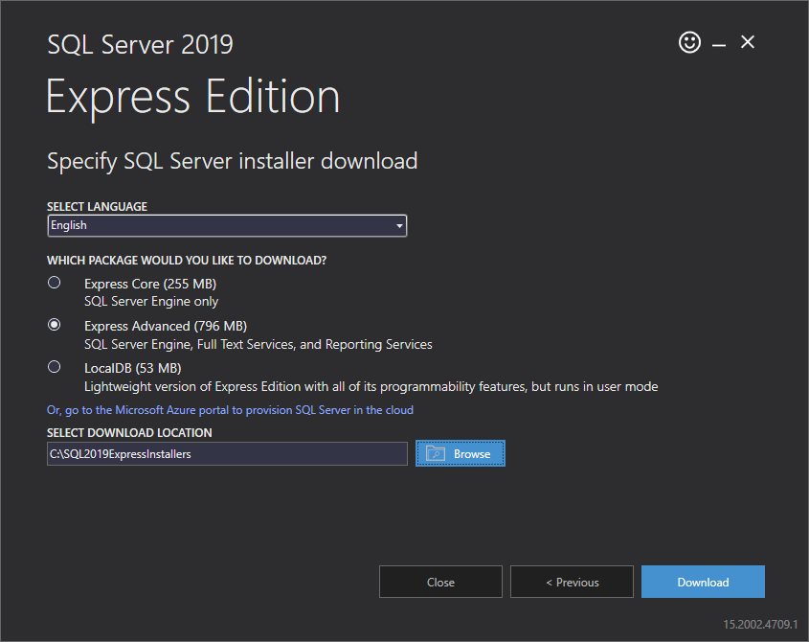

“Click” on the “Download” button to start downloading the offline installer.

The download will start and the below screens will be displayed showing the download progress.

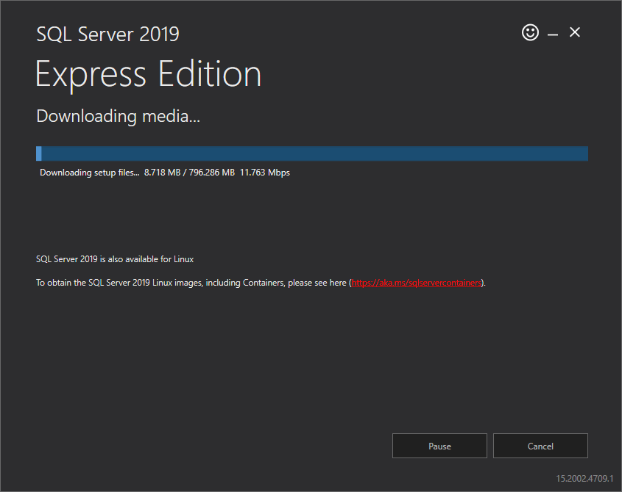

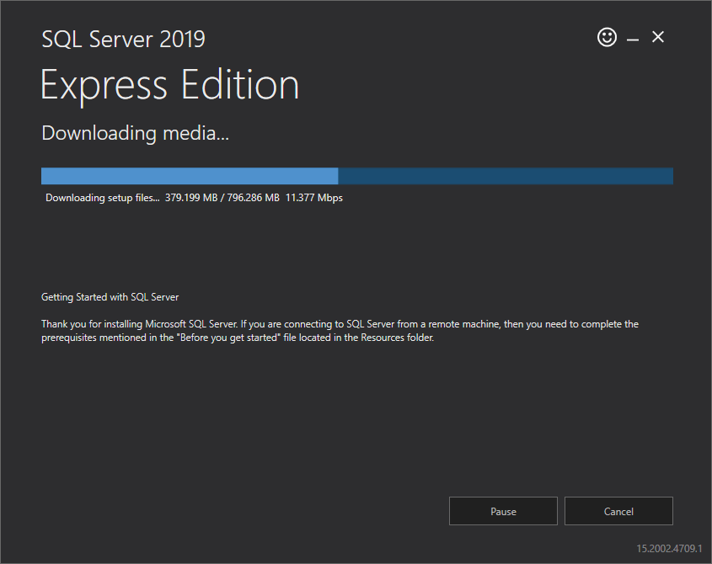

Once the download is complete, “click” on the “Open Folder” button.

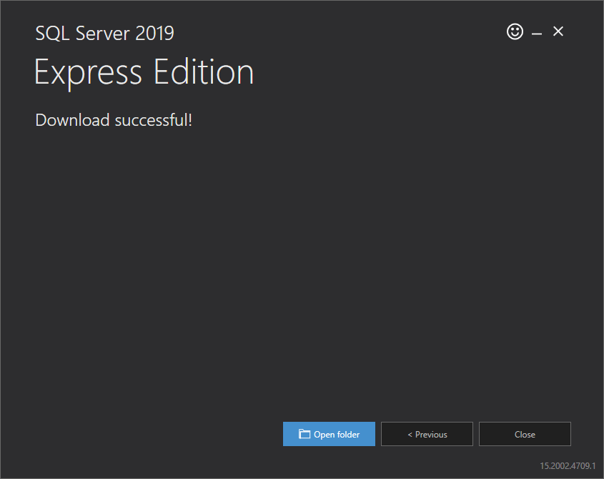

Double Click the SQLEXPRADV_x64_ENU.exe

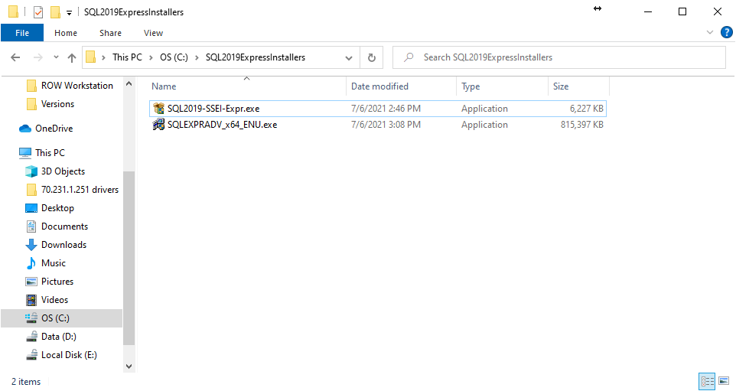

Click on “OK”
The exe will extract it’s contents to a folder next to the SQLEXPRADV_x64_ENU.exe file called SQLEXPRADV_x64_ENU.

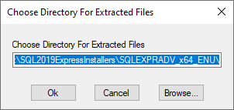

Once it is done extracting, the SQL Server Installation Center will automatically start. Shown below.
When installing SQL Server, click on the “New SQL Server stand-alone installation or add features to an existing installation” link.

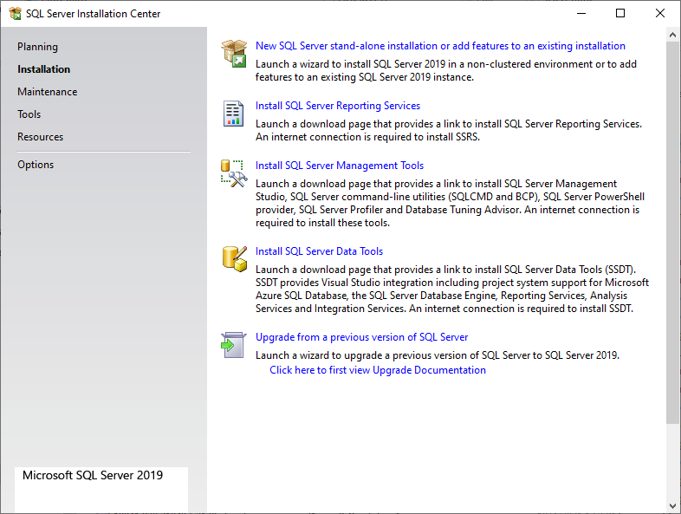

Accept the license terms and privacy state statement.
Click on the “Next” button.

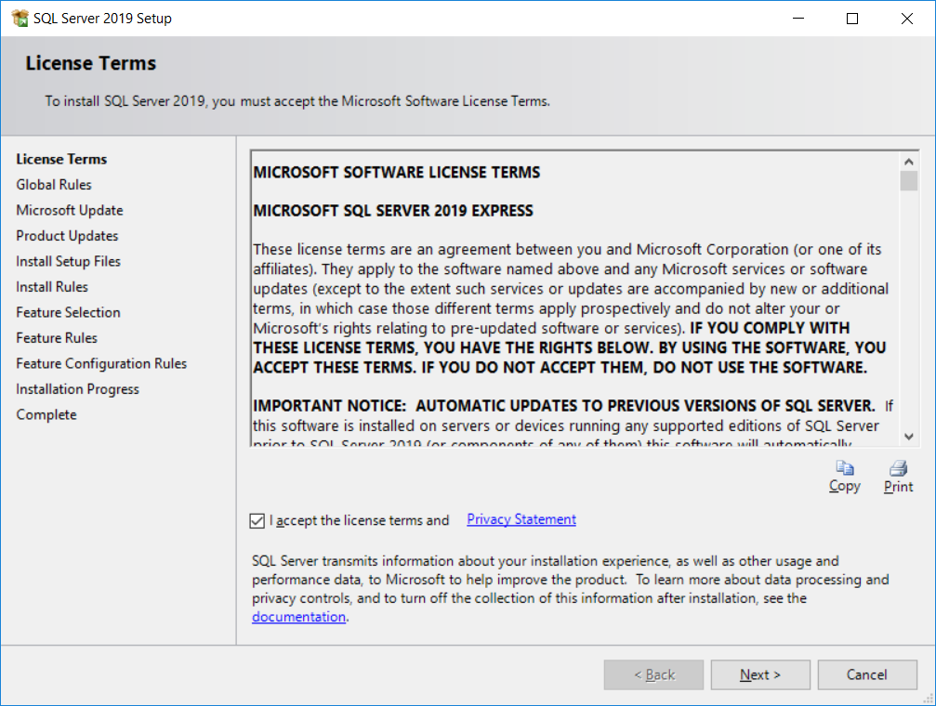

If prompted, you can have Windows update check to see if there is an updated version available.
The Installation program will perform some checks on the installation files and then install the setup files.

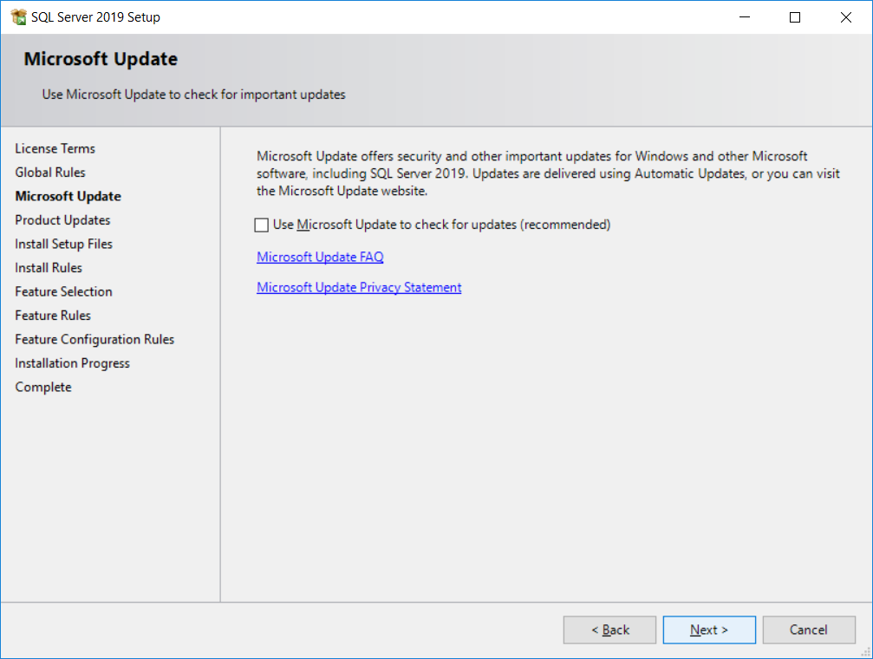

If you are not connected to the internet, you will see the below screen when setup checks for newer installation files on Microsoft’s website. Click on the “Next” button to continue with the installation process.
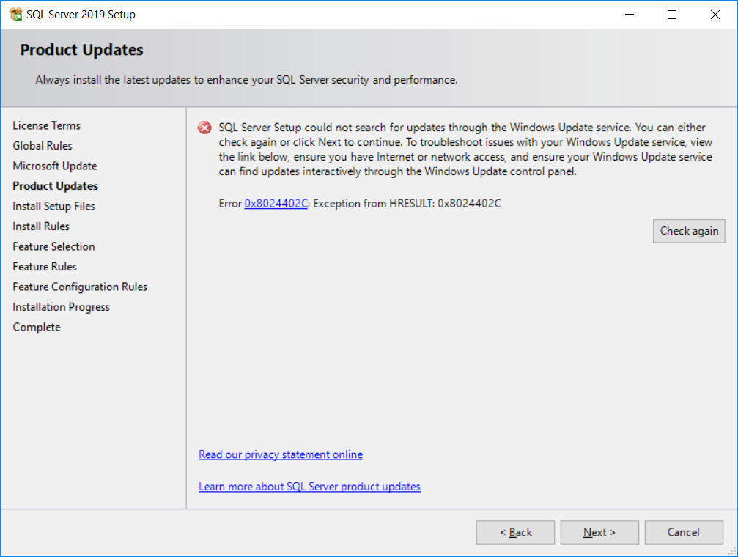
Setup will perform some checks on your system and let you know if it finds anything that could be a problem.
In the example below, the windows firewall is enabled on this system, setup displays a warning to make the user aware of this systems configuration. Some ports will need to be opened for remote systems to connect to SQL server after installation. TCP 1433
Click “Next” to continue.
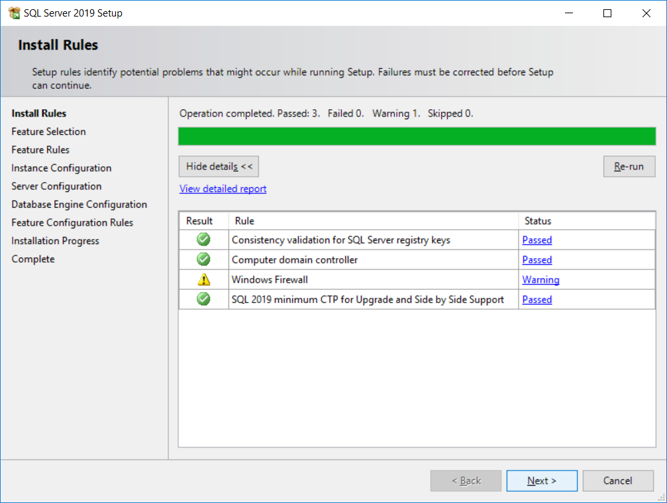
Verify the “Database Engine Services” box is checked, and then click “Next” to continue.
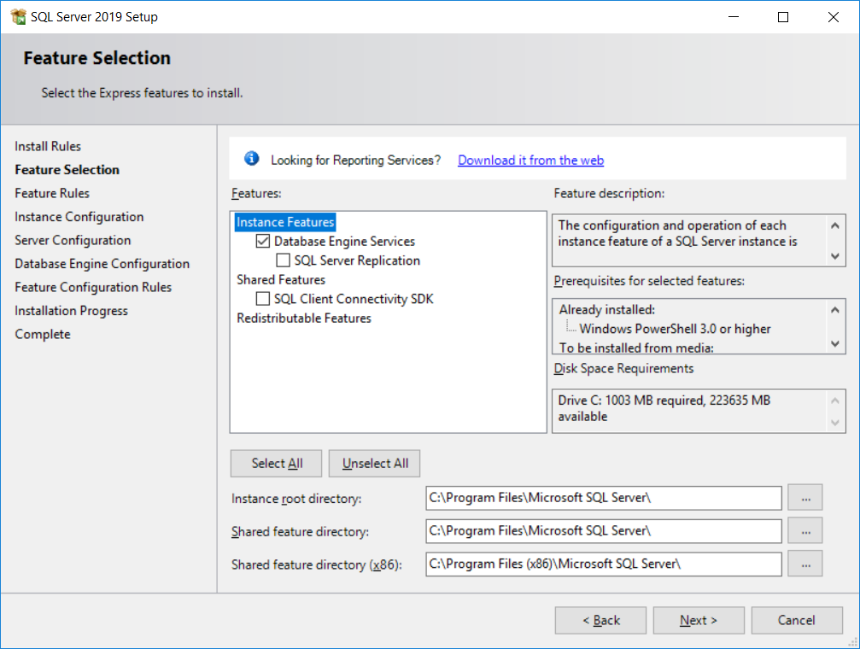
Setup will determine the next available selection.
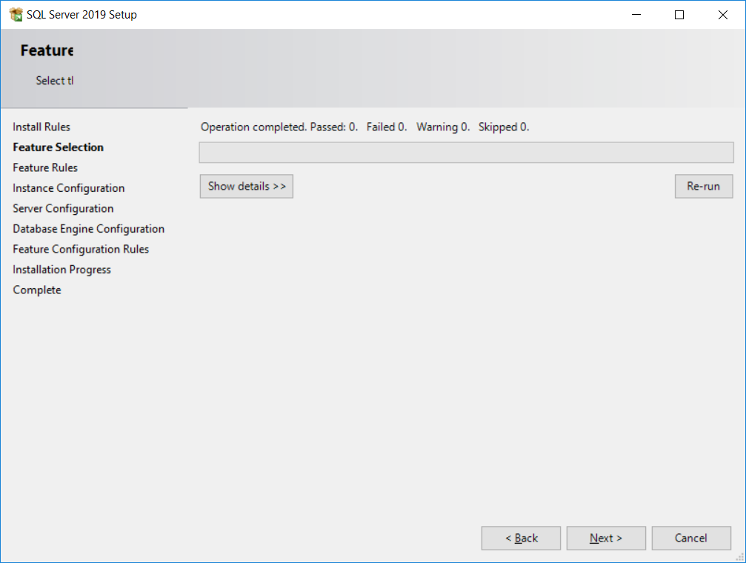
Select “Default Instance” and click “Next” to continue.
The Instance ID will be “MSSQLSERVER”
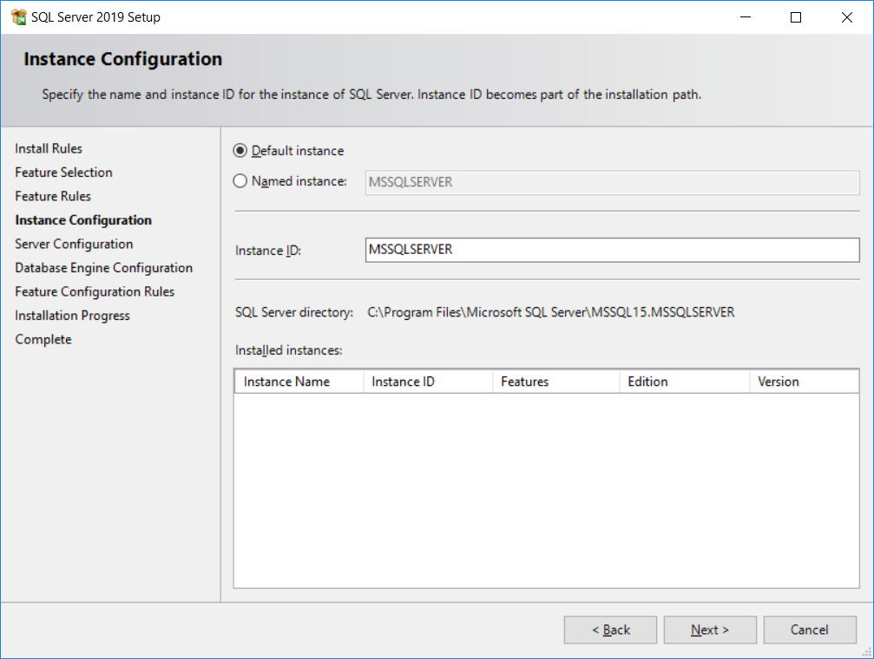
Click “Next” to continue.
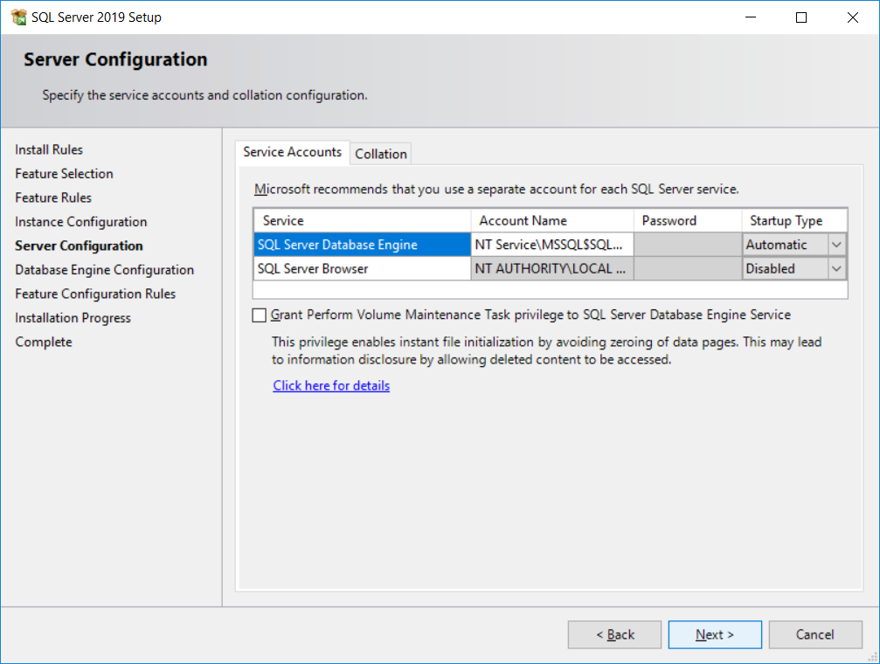
Select “Mixed Mode (SQL Server authentication and Windows authentication)
Type in the password “OSAdmin123!@#” and click “Next” to continue.
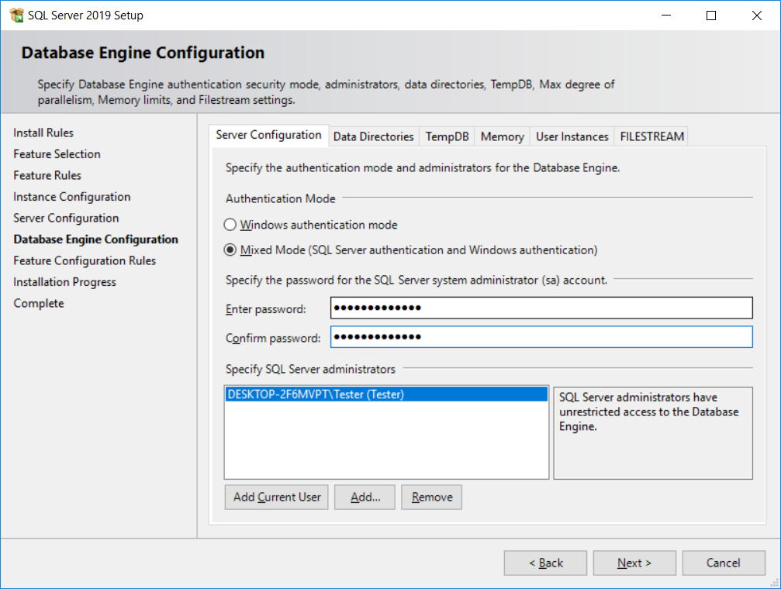
Setup will start copying files to your server.
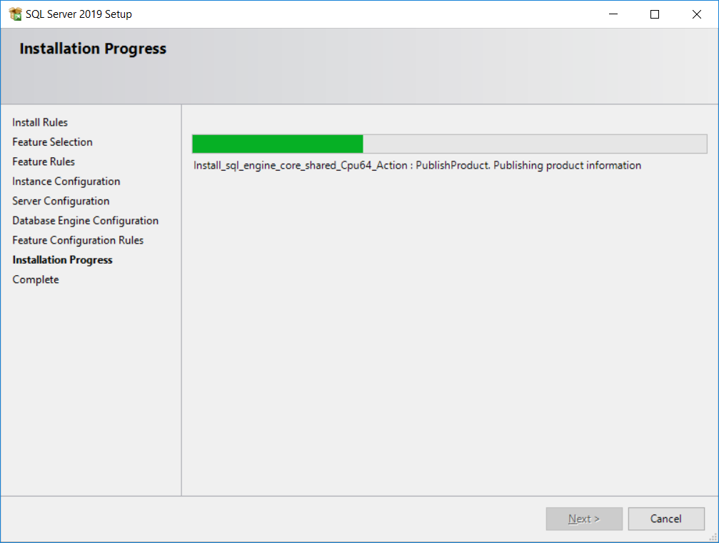
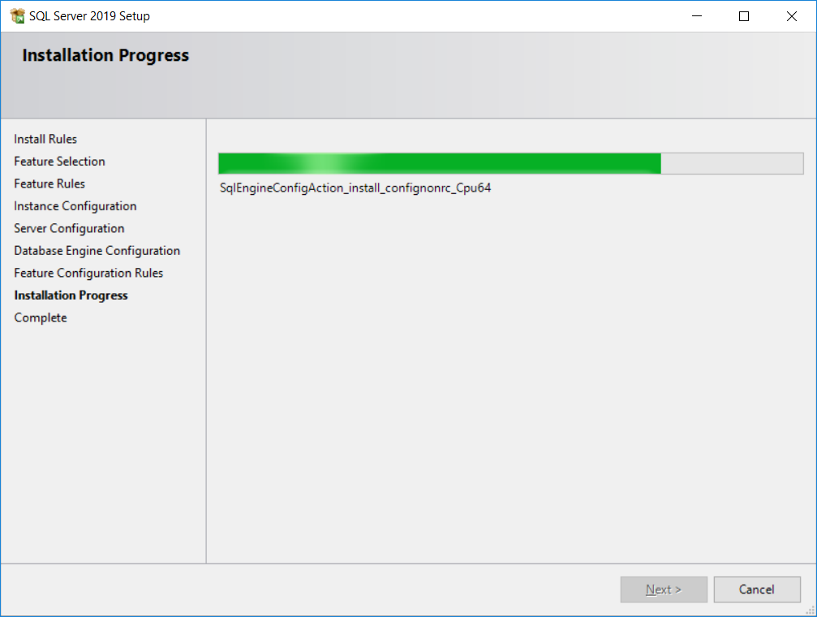
Once SQL Server setup is complete, you will see the below screen with the status for each component.
In this example, no errors were reported.
Click “Close” to complete SQL Server setup.
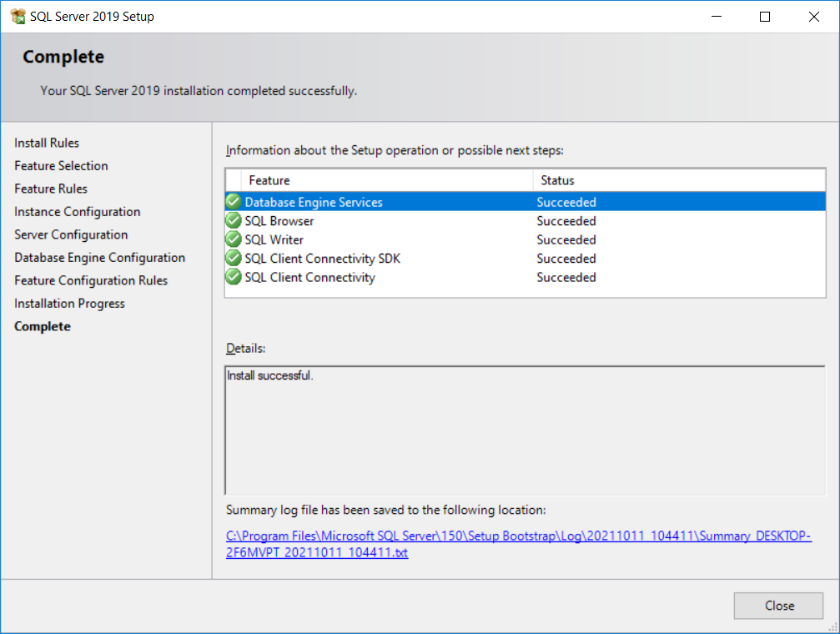
The next section will describe how to configure SQL Server. Continue to the next section.
  - SQL Server 2019 Express - Configuration
Open SQL Server 2019 Configuration Manager under:
Microsoft SQL Server 2019 Configuration Tools SQL Server 2019 Configuration Manager.
Select SQL Server Network Configuration and click on Protocols for MSSQLSERVER
Double click on TCP/IP and change to Yes

Click on the “IP Addresses” tab. Find you Server IP and Enable IP4 and type in the TCP Port 1433. Click “OK”

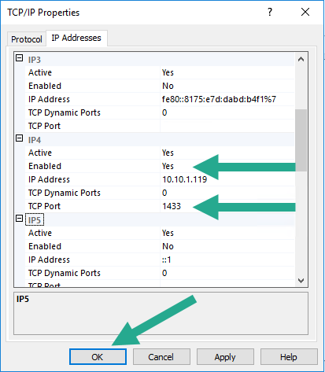
Restart SQL Server by click on SQL Server Service. Then on the right side of the screen right-click on SQL Server (MSSQLSERVER) and click on Restart to apply the change.

Close SQL Configuration Manager

  - SQL Server 2019 Management Studio – Create the SQL User for the DPK Injection process
Open SQL Management Studio.
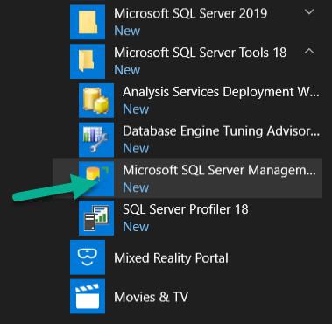
Notes:
- If you get an error, we had to run the .NET repair tool.
- You can also run the setup and select maintenance to fix issues.

Open SQL Management Studio and connect to the SQL Instance. Use Windows Authentication to connect. If you are logged in as the Administrator for the server, you will be able to access SQL Server. Click “Connect”.
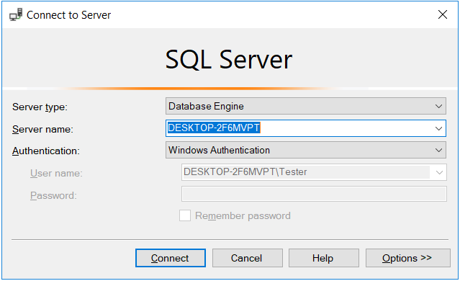

Click on Security then Login. Right click and select New Login.
Important Note: Make sure Enforce password policy is not checked, as well as Enforce password expiration and User must change password on next login which shows grayed out in this example.

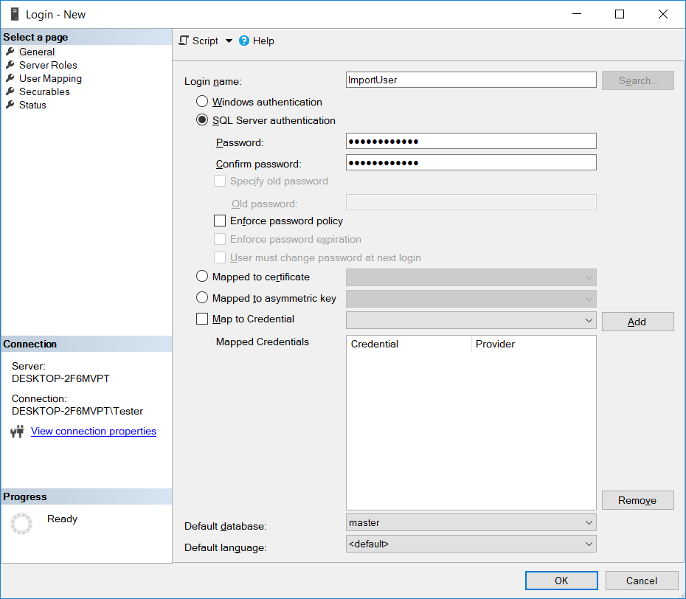

Type in the username and password to be used for the database.
User: ImportUser
Password: Import123!@#
Note: if you change this password from the one above you will need to run the command below to set the correct encrypted password in the SDS_DPK.ini.

Adding the SQL account password to the SDS_DPK.ini
To set the password in the SDS_DPK.ini you will need to run this command. This command will encrypt the password and update the INI file with the password.
C:\>SDS_DPK.exe /SET_PASSWORD:”Import123!@#” (or the password for sql account if different)
Click on “OK”
Once the user is added – double click on it and give it just 2 permissions: Connect SQL and Create any Database
Important Note: DO NOT USE ADMIN credentials for this account for the best security.

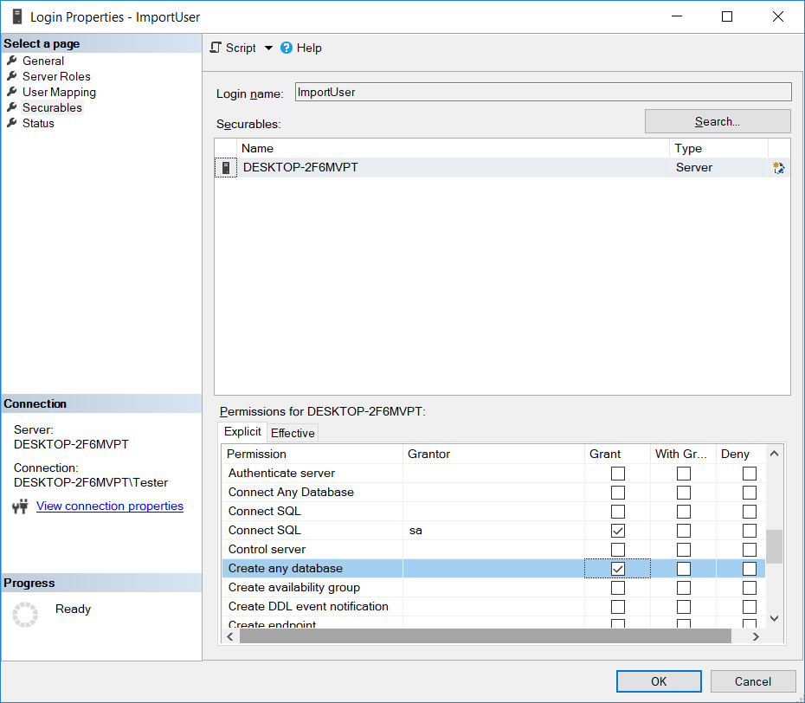

The new SQL account that you just created will be used to do the following:
- Create the Database on first use.
- Create the table with Fields and Datatypes

Configuring DPK Tool for your location

  - Add SQL account password you created above to the SDS_DPK.ini by running the below command.
  - SDS_DPK.exe /SET_PASSWORD:”Import123!@#”
  - Edit the SDS_DPK.ini
  - Change the IP address to match your DPK database server. Example: server=192.168.0.2,1433
  - database=DPKDB
  - login=ImportUser – sql server login
  - password= the password is encrypted using the command line in step 1.
  - dpkppid_file_location=%dpkppid.txt path and file name%
    - (If this field is not defined the default location is C:\OA30\DPK)
    - Valid if 23 or 20 characters in length only
    - Detecting execution under Winpe: If dpkppid_filePath was setup to save to C:\OA30\DPK\dpkppid.txt it will be changed on the fly to X:\OA30\DPK\dpkppid.txt
  - OBA= Elapsed Day check for OBA is added to the .ini. 0 will deactivate this feature
[Database]
Elapsed_days_check=5
- Add: new setting to automatically reuse DPK if possible. It will need to be used with the elapsed day check in the .ini file. (Disabled by Default)
[options]
auto_reuse_dpk=1
- Add: Setting to each BIOS tool to ignore an error on Reset only. Phoenix is turned on by default. You only need to have an entry currently for Phoenix.
[options]
Ignore_Phoenix_Tool_Error=1
Ignore_Ami_Tool_Error=
Ignore_Dell_Tool_Error=
Ignore_Insyde_Tool_Error=
Ignore_Inventec_Tool_Error=
- Add security around setting dpk to corrupted status to avoid purging all dpks.
- The rest of the settings in the SDS_DPK.ini can be left at the default settings. (see sample below)
- All available settings are outlined in the Appendix under the SDS_DPK.ini section.


Create the DPK Database and Import/Export DPKs

SQL Server connection test
Open an administrative command prompt and change to the DPK tools directory.
Type in SDS_DPK.exe /TEST_CONNECT to test the connection to the SQL Server. If you get an error when you run this command, go directly to Database Creation section.
Check the SDS_DPK.log for to verify there are no errors connecting to the SQL server.
Note: If you forgot to uncheck the Enforce password policy and Change Password on next login when setting us the SQL User, you may get an error. Change the settings if so, not the configuration. You may need to delete the User and set it up correctly.

Database creation
Create the DPKDB in the SQL database by typing the below command at the DPK tools directory.
Type in SDS_DPK.exe /INSTALL_TABLE
Check the SDSDPK.log to verify there are no errors creating the database.

DPK Import to database from csv file
Important Note: Never open and save the .csv in Excel! It will change the formatting and fail to import!
To import DPKs from a csv file,
Type in SDS_DPK.exe /IMPORT:”dell_dpk.csv”
where dell_dpk.csv is the name of the csv file received from Dell
Check the SDSDPK.log to verify there are no errors creating the database.
SQL Table will adjust to the encryption types needs automatically.

DPK Export from database to a csv file to reclaim DPKs
Important Note: Never open and save the .csv in Excel! It will change the formatting and fail to import!
To export DPKs to a csv file, in the case that they need to be reclaimed by Dell.
Type in SDS_DPK.exe /RECLAIM:50,”DPKExport1.csv”
where DPKExport1.csv is the name of the csv file that will be created of the reclaimed DPKs
Can only do a Maximum of 50.
Must type in the password for the DPK Database to run this command (max of 3 attempts).
It will not overwrite an existing .csv, so each export must have a unique name.
The reclaimed DPKs will be set to a status of 32 in the database.

Put a DPK on standby to Rework an MBD
Add a switch “STANDBY_REWORK” to put current computer DPK 'on hold'/'Standby' into SQL database in order to rework on computer.
Type in SDS_DPK.exe /STANDBY_REWORK
- Put the DPK in Standby
- Erases the DPK from the MBD

Reuse a DPK that has a status of in use for a set number of days
To reuse a DPK that has been left in use when the status cannot be communicated back to the database.
Type in SDS_DPK.exe /RECOVER_INUSE
  - InUse_days_check -> recover with /RECOVER_INUSE.
  - lapsed_days_check -> for Out of Box Audit (OBA), tool allow to reflash PPID computer with same DPK if an elapsed day trigger is met.
  - Both of these are used together.

Query the database for a count of available DPKS
The way to check is to do a query on the SQL server.
Select count (*) from DPKDB.dbo.DPK_ENTRIES where Status = ‘1’ and DELL_PN = ‘JN38V’
If the site has both DELL and WYSE keys then you can do these separately to know how many of each part number they have.

DELL DPK Keys
Select count (*) from DPKDB.dbo.DPK_ENTRIES where Status = ‘1’ and DELL_PN = ‘JN38V’

WYSE DPK Keys
Select count (*) from DPKDB.dbo.DPK_ENTRIES where Status = ‘1’ and DELL_PN = ‘3RG26’

Auto Pilot Deregistration

Modify the DPK Database to add Auto Pilot Deregistration for existing versions before moving to 1.0.0.64

    - Backup the current DPK database
    - Perform this update of the DPK database while production is paused. The update should take approx. 5 minutes depending on the size of the database.
    - Open an administrative command prompt and change to the DPK tools directory.
    - Type in SDS_DPK.exe /TEST_CONNECT to test the connection to the SQL Server
Important Note:
Make sure you are using SDS_DPK.exe version 1.0.0.64 to perform the SDS_DPK.exe /TEST_CONNECT command to update the database with the correct columns. Prior version will not make the needed change.
    - Check the SDS_DPK.log for to verify there are no error connecting to the SQL server.
    - Check the DPK Database of the addition or the following columns
    - AUTOPILOT_MARKER
    - AUTOPILOT_FLAG
    - The SDS_DPK.log will contain these entries when updating the database with the SDS_DPK.exe /TEST_CONNECT
    - Database does not contain all proper necessary fields, updating table...
    - AutoPilot entries added successfully to database table
    - Autopilot UEFI fields are recorded to SQL database and reset during the SDS_DPK.exe /AUTO /PN:”DELL” DPK injection command.
    - If Autopilot information is present, you will see the log entries below and Autopilot Marker and Autopilot Flag will be recorded to SQL database.

Auto Pilot Logging

    - The SDS_DPK.log will contain these entries when updating the database with the SDS_DPK.exe /TEST_CONNECT and using 1.0.0.64 or higher.
    - Autopilot UEFI fields are recorded to SQL database and reset during the SDS_DPK.exe /AUTO /PN:”DELL” DPK injection command.
    - If Autopilot information is present, you will see the log entries below and Autopilot Marker and Autopilot Flag will be recorded to SQL database.
- AutoPilot Network flag is present: 0
- AutoPilot Network flag reset to 0 succesfully
- AutoPilot marker is present: {6FD22FF9-1462-473F-83DA-18A8A4A071F9}
- AutoPilot marker flag reinitialized successfully
    - If Autopilot information is not present on the system, you will see the log entries below and Autopilot Marker and Autopilot Flag will be NULL in the SQL database. This is because the Autopilot information was not present on the system to record.
- AutoPilot Network flag not present
- AutoPilot Network flag reset to 0 succesfully
- AutoPilot Marker not present
- AutoPilot marker flag reinitialized succesfully
- Autopilot UEFI presence not detected, status code = 2

ARM64 Support for DPK Injection

New Executable for ARM64 Qualcomm Devices. SDS_DPK_A64.exe

  - Windows Requirements
Use Windows 11 ARM64 version. It must have .net support.
Important Note: Make sure you are using SDS_DPK_A64.exe for ARM system repair scripts in Windows for best performance.

  - WinPE Requirements if running under WinPE
Use Dell WinPE Windows 11 ARM64 version. It must have .net support.
Important Note: Make sure you are using SDS_DPK_A64.exe for ARM system repair scripts. If you run the SDS_DPK_A64.exe on Windows x86 or x64 systems you will see this error.
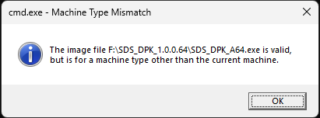
We are releasing a version of Winpe that will support ARM64 based on ficore_utility_stick_a4_153_03a001.exe. For background the Windows 11 ARM64 WinPE packages required for DPK decryption and injection are below. In order to run the Winpe must have complete .NET support for Dell DPK decryption tool. These packages need to be installed in this order.
  - WinPE-WMI.cab
  - WinPE-NetFX.cab
  - WinPE-Scripting.cab
  - WinPE-PowerShell.cab
  - WinPE-DismCmdlets.cab
  - WinPE-SecureBootCmdlets.cab
  - WinPE-StorageWMI.cab
  - WinPE-SecureStartup.cab
  - WinPE-PPPoE.cab
  - WinPE-MDAC.cab
  - WinPE-RNDIS.cab
  - WinPE-WinReCfg.cab
  - WinPE-PlatformId.cab
  - Files added for ARM support
BIOS tool name and version for the Warlock NQ ARM64 system
QCFactoryTool.exe version 1.0.1600.0 If the BIOS tool changes, the below files need to change to match it.

- qcfactory.sys version 1.0.1600.0
- qcfactory.cat
- qcfactory.inf

  - Tools Requirements for ARM

- To read the EPPID you must use the repair tool WosRwEEPROM.
- To get the EPPID using WosRwEEPROM
  - WosRwEEPROM /r 0 10 2F /e EPPID
- Then run the EPPID.cmd or read it to get the EPPID of the system

  - Change needed for the SDS_DPK.ini
Add the below to the SDS_DPK.ini highlighted in Yellow:

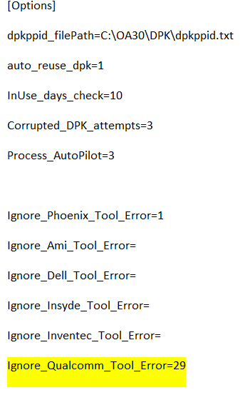

Windows 11 OS configuration

Need these modifications made with Windows 11 Update (22H2) and possibly Windows 10.
Microsoft’s latest Windows 11 feature update, the Windows 11 2022 Update (22H2), turns on the operating system’s core isolation memory integrity protection and enables the use of a registry setting VulnerableDriverBlocklistEnable by default. This can cause some tools to be blocked from running, including the AMI BIOS Driver used by SDS_DPK.exe to ERASE and Inject DPKs on AMI BIOS systems. And possibly some Dell tools such as PlatCFG64W.exe.

For the AMI BIOS tools you may see this error if these settings are enabled.
A security setting is detecting this is a vulnerable driver and blocking it from loading. You need to adjust your settings to load this driver.

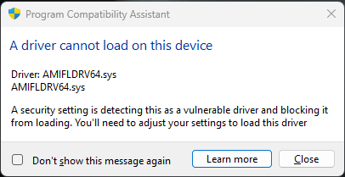

You will see these errors in the SDS_DPK.log file.
Could not Reset MSDM ACPI table with tool: C:\Users\Tester\AppData\Local\Temp\sds.dell.resources_123456709876_123212\amioa64.exe, status code = 16
Use the alternate tool available C:\Users\Tester\AppData\Local\Temp\sds.dell.resources_123456709876_123212\AMI2\amioa64.exe
Could not Reset MSDM ACPI table with tool: C:\Users\Tester\AppData\Local\Temp\sds.dell.resources_123456709876_123212\AMI2\amioa64.exe, status code = 16
Use the alternate tool available C:\Users\Tester\AppData\Local\Temp\sds.dell.resources_123456709876_123212\AMI3\amioa64.exe
Could not Reset MSDM ACPI table with tool: C:\Users\Tester\AppData\Local\Temp\sds.dell.resources_123456709876_123212\AMI3\amioa64.exe, error code = 16
SDS_DPK tool finished -- , error code = 8

To work around this, you will need to disable these 2 security features with the following steps:
If this is on a customer system OS, you will need to re-enable these settings before you ship the system back to the customer.
Under Windows Security - Disable Core Isolation à Memory Integrity Set Memory Integrity to Off

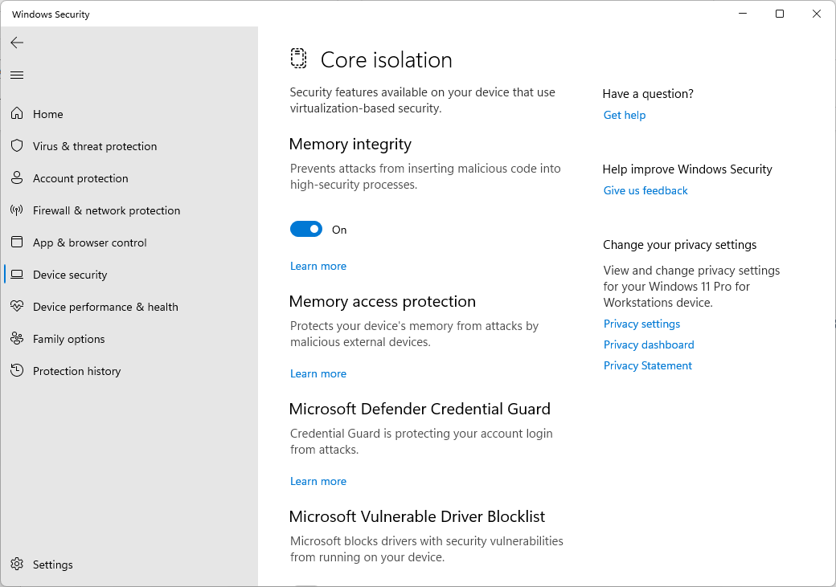

Set registry to disable VulnerableDriverBlocklistEnable setting – set it to 0
Registry location:
[HKEY_LOCAL_MACHINE\SYSTEM\CurrentControlSet\Control\CI\Config]
"VulnerableDriverBlocklistEnable"=dword:00000000
Reboot the system for the 2 changes to be used.

Executing the DPK Tool

Flash / Inject new DPK

Run this command to flash the motherboard with a new DPK
  - SDS_DPK.exe /AUTO /PN:"DELL" -> first available DELL DPK JN38V part number
  - SDS_DPK.exe /AUTO /PN:" WYSE" -> first available WYSE DPK 3RG26 part number
Notes: Must designate the part number

Once DPK is requested for the system, it is marked for pending update.
If the flash is successful, the DPK is marked as used in the database.
If there is a flashing error, the DPK is marked valid again in the database.
If there is problem flashing due to corrupt DPK it is marked as not valid.
To only Clear the DPK (for Motherboards to be scrapped) run the below command.
SDS_DPK.exe /ERASE
This will reset computer MSDM table, the switch is exclusive and cannot be used with any other.
To only Verify the DPK has been injected properly, run the below command.
SDS_DPK.exe /VERIFY
If the DPK is not valid (5 by 5 string) then error=30. 0 is success.
Need a reboot after DPK inject to run this command
The last 5 will be blanked in the log for security reasons
For OBA, if the MBD is chosen for Audit, the tool will allow to reflash PPID computer with same DPK. The trigger of Days is set in the SDS_DPK.ini and can be modified. If the elapsed day trigger is met, a prompt to Reuse (R) or New (N) is shown.
[Database]
Elapsed_days_check=5

DPK Tool Error Codes

DPK Tool error codes
Can also be retrieved with “echo %ERRORLEVEL%” at the command prompt

0 - OK
1 - could not find temp folder to use for internal flashing tools
2 - could not find input.xml to configure OA3.cfg file
3 - could not export Dell tools zip file
4 - could not open zip file
5 - could not extract zip file
6 - could not create oa3.cfg file
7 - could not find valid flashing tool compatible with system
8 - could not reset MSDM ACPI table
9 - /// old version: could not write MSDM ACPI header error to prepare oa3.bin write operation
10 - could not write oa3.bin file
11 - could not prepare working environment from 'DPK_TOOLS' folder next to application
12 - could not open the database requested
13 - could not create the DPK table in the specified database
14 - could not find a free DPK entry available
15 - could not reserve DPK in database
16 - could not report DPK flash operation to database
17 - invalid DPK/PKID length
18 - invalid DPK/PKID data content
19 - could not create oa3.xml file (hardware hash CBR file)
20 - could not import the csv file to the database table DPK_ENTRIES
21 - could not report back the oa3.xml as CBR to database table DPK_ENTRIES
22 - not A valid system (Dell/Alienware)
23 - another tool instance is already running
24 - need to reboot the computer to allow to report the CBR to database
25 - invalid environment (Specified mac address computer not found on network)
26 - reboot tag file contains abnormal DPK_ID for report
27 - .NET 4.5 CLR or greater not detected
28 - Part number defined not found in INI
29 - Cancel operation, no valid PPID provided
30 - MSDM ACPI table does not contain a valid DPK
31 - corrupted DPK found in database table
32 - reclaimed DPK command invalid, an existing .csv file exits or the password was incorrect.
34 - RECOVER_EOL Error code 34 if the process failed.
35- STANBY_REWORK Error code 35 if the process failed.

For version 1.0.0.45 an error may be seen on some legacy systems with the new DellOA3 tool.
In version 1.0.0.47 we will switch automatically to the previous DellOA3 tool in the errors is see.
In Version 1.0.0.51, we added a new AMI Bios tool needed for newer platforms that we will switch to automatically if the current AMI Bios tool fails
Logging looks like:
[06-01-2021 13:36:19.088] : Could not Reset MSDM ACPI table -> internal tool: C:\Users\ADMINI~1\AppData\Local\Temp\sds.dell.resources_123456709876_123212\delloa64.exe, error code = 255
[06-01-2021 13:36:19.119] : Flashing tool error, use the alternate method available...

Input Requirements

To capture the correct PPID, the TPR will scan the PPID from the sticker on the motherboard or traveler and put it in a file.
The default location is C:\OA30\DPK directory
The location can be changed in the SDS_DPK.INI in needed (See SDS_DPK.INI Configuration Section)
The file name must be dpkppid.txt (attached example)
Valid if 20 or 23 characters only.


To get the PPID, SDS_DPK tool will read the value from the text file.
If the text file does not exist, it will give the option for either type or scan the PPID. See screenshot below
We will check to see if the PPID is 20 or 23 characters. If the PPID string length does not match 20 or 23 characters with the following characters used 0-9,a-z,A-Z, it will error.

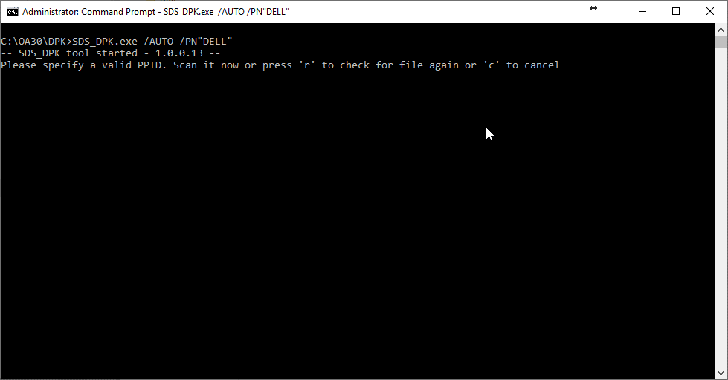

Script Integration

Remove clearing the DPK from all start up and test scripts.
If you are running the test script from a USB key, ensure that the dpkppid.txt is deleted from c:\Oa30\DPK as well as the SDS_DPK.log from c:\Oa30\DPK.
Add a Robocopy command to the startup.bat to copy down the DPK Utility from the mapped network drive.
Add the Command to run the utility, copy logs, and clean up after to the Test script after all functional tests have completed. (Example is when drive mapped as X:)

**IMPORTANT: Only run mfgmode64w +SMMM > mfgmode.txt after all DPK Injection & Verification process has completed. Doing this in conjunction with Service Reset will clear the DPK!!
Order is as follows:
Service Reset
Inject DPK
Reboot
Verify DPK
Set Service Menu
Shutdown Right after setting the service menu

- Start up batch Robocopy section
robocopy X:\DPK c:\oA30\DPK\ *.* /E /Z /TBD /MIR
- Test Script changes
:DPK
cd\
cd c:\OA30\DPK\
call SDS_DPK.exe /AUTO /PN:"DELL"

:REBOOT

call SDS_DPK.exe /VERIFY

:LOOP for Retry Once complete add next section

if exist X:\DPK_LOGS goto copydpklogs else goto mddpklogsdir
:mddpklogsdir
md X:\DPK_LOGS
:copydpklogs
copy c:\OA30\DPK\SDS_DPK.log X:\DPK_LOGS\"%ppid%".log
pause
cd\
DEL c:\0a30\DPK /f /s /q

Script Update for Verify Stability

This update is important to ensure that the DPK verify process works correctly.



:DPK
cd\
cd c:\OA30\DPK\
if exist c:\oa30\dpk\dpkppid.txt del c:\oa30\dpk\dpkppid.txt
echo %EPPID% >c:\oa30\dpk\dpkppid.txt
call SDS_DPK.exe /AUTO /PN:"DELL"
if %ERRORLEVEL% EQU 14 (goto DPK_OUT)
if %errorlevel% EQU 0 (goto DPK_INJECT_MSG) else (goto DPK_FAIL_MSG)

:DPK_Verify
cd\
cd c:\OA30\DPK\
call SDS_DPK.exe /VERIFY
pause
if %errorlevel% EQU 0 (goto DPK_PASS_MSG)
SET /A count_DPK+=1
if %count_DPK% leq %MAXINV% ( goto DPK_MSG ) else ( goto DPK_FAIL_MSG )

:DPK_INJECT_MSG
cls
color 0a
echo.
echo =============================================
echo = DPK INJECTED !!! =
echo =============================================
echo.
echo ====================================
echo = SYSTEM WILL REBOOTE =
echo = CONTINUE WITH TESTING =
echo ====================================
echo.
pause
echo DPK Injection DONE >"%TEST_LOG%\%sn_log%_DPKINJECTION.txt"
if exist P:\DPK_LOGS goto copydpklogs else goto mddpklogsdir

:DPK_MSG
cls
echo.
echo ******************************************
echo * DPK Injection can not be validated *
echo * *
echo * Hit ENTER to retest *
echo ******************************************
echo.
pause
goto DPK

:DPK_PASS_MSG
cls
color 0a
echo.
echo ======================================================
echo = DPK Injection VERIFIED =
echo = =
echo = DPK Injection Successful!! =
echo ======================================================
echo.
pause
::bNETLOG need to be set here because of the DPK Injection Verification
set bNETLOG=true
if exist P:\DPK_LOGS goto copydpklogs1 else goto mddpklogsdir1

:DPK_OUT
cls
echo.
echo ======================================================
echo = DPK Database has consumed all DPK's =
echo = Contact your DPK administrator for more =
echo ======================================================
echo.
pause
goto DPK_OUT

:DPK_FAIL_MSG
cls
echo.
echo ======================================================
echo = DPK Injection FAILED!! =
echo ======================================================
echo.
pause
if exist P:\DPK_LOGS goto copydpklogs2 else goto mddpklogsdir2

REM *** DPK INJECTION ***
:mddpklogsdir
md P:\DPK_LOGS

:copydpklogs
copy c:\OA30\DPK\SDS_DPK.log P:\DPK_LOGS\"%ppid%".log
shutdown /r /t 1
pause

REM *** DPK VERIFICATION ***
:mddpklogsdir1
md P:\DPK_LOGS

:copydpklogs1
copy c:\OA30\DPK\SDS_DPK.log P:\DPK_LOGS\"%ppid%".log
rd c:\OA30 /S /Q
goto cont

REM *** DPK FAILED ***
:mddpklogsdir2
md P:\DPK_LOGS

:copydpklogs2
copy c:\OA30\DPK\SDS_DPK.log P:\DPK_LOGS\"%ppid%".log
rd c:\OA30 /S /Q
goto fail

Database Structure

DPK Table Fields and Data Types

Field Name | Data Type | Description
ENTRY_ID | bigint identity primary key | used internally to the database only
DELL_PN | varchar(16) not null | // Dell PN (from csv)
FACILITY | varchar(16) | // ?? (from csv)
DPK_ID | varchar(13) not null | // DPK_ID ((from csv))
DPK | varchar(256) not null | // DPK (from csv) could be RSA encrypted or clear text
IMPORTE_DATE | datetime not null | // date of the DPK (from csv)
STATUS | integer not null | // Status evolution bit field -> 1=Available | 3=in PROGRESS | 7=Complete | 8=Invalid | 32=Reclaimed
SITE_ID | integer | // -- not used
OLD_DPK | varchar(32) | // Old motherboard BIOS DPK as clear text
USAGE | date | // date of DPK usage
PPID | varchar(32) | // Motherboard PPID
XML_REPORT | varbinary(MAX) | // XML report from OA3 tool

Status Field notes:
- Status=1 - Query a 'valid DPK' then decrypt if necessary. Only use DPK with (status=1)
- Status=3 - When first request DPK, mark DPK as “In USE” so it will not be requested twice. Set (status=3)
- Status=7 - When successful and all data is written back to database, set (status=7)
- Status=1 - if error and DPK not used. DPK is marked available again, set (status=1)
- Status=8 – If the DPK is invalid, set (status=8)
- Status=32-If a DPK is reclaimed and exported, change status to 32 so it will not be used nor will not be re-imported.

Recommendations

Backup Strategy
Set up the backup in SQL Express, and if needed set a schedule to run in Windows Task Scheduler.
Please see the link below for step by step instructions.

https://www.reliasoft.com/sql-server-express-backup-instructions

Some notes below:
If your version of SQLExpress is SQL Server 2014 Express – the below path will match, if you are using another version then search the “C:\Program Files\Microsoft SQL Server\” directory for the SQLCMD.exe to find the path to it. Then use that path in your command.
"C:\Program Files\Microsoft SQL Server\Client SDK\ODBC\110\Tools\Binn\SQLCMD.exe"

If SQL was installed using SQLEXPRESS Instance – use this command parameter
-S \sqlexpress -i "C:\SQLBackup\DPKDB_Backup_Script.sql"

If SQL was installed using default instance – use this command parameter
-i "C:\SQLBackup\DPKDB_Backup_Script.sql"

Appendix

SDS_DPK.ini
- Adding the SQL account password to the SDS_DPK.ini
  - In order to set the password in the SDS_DPK.ini you will need to run this command. This command will encrypt the password and update the INI file with the password.
  - C:\>SDS_DPK.exe /SET_PASSWORD:”Import123!@#” (or the password for sql account if different)
- Configuring the remaining settings:
  - server=192.168.0.2,1433 (this is only an example)
    - Set this to the Server IP address of the NIC you will be connecting to the server from the UUT for testing. The port will be 1433 by default unless a change is needed.
    - The IP address may change at each TPR location depending on Network requirements.
  - database=DPKDB
    - Name of the database that will be created on first run of the SDS_DPK.exe with the /INSTALL_TABLE switch
[Database]
server=192.168.0.2,1433
database=DPKDB
login=ImportUser - sql server username created earlier in this document.
Password=encrypted password – set with the command in the prior step.
Elapsed_days_check=5
-> 0 will deactive the feature

[Import]
separator=; - separator in the CSV file.
skipline=1 – leave the default, will skip to the next line during import for each line.

[Report]
SendOldDPK=1
SendCBR=1

PS: for both of those settings by default (=0), SQL data will contain 'Skipped by setting'
By default it is skipped (=0).

[PN]
DELL=JN38V
WYSE=3RG26
OTHER=xxxx

[Options]
Corrupted_DPK_attempts=3
Can be changed to set number of DPKs that can be set to Corrupted in the database at one time
dpkppid_filePath=C:\OA30\DPK\dpkppid.txt
default path to the dpkppid.txt, is configurable using this setting.
auto_reuse_dpk=1
To be used with Elapsed_days_check to automatically choose Reuse with a prompt
The x number of days is defined by the “Elapsed_days_check=x” – where 5 is the default setting for 5 days
InUse_days_check=10
Used with the /RECOVER_INUSE command
This number defines the number of days since a DPK was attempted to be use and the database was not updated to a status of 7 and was left at a status of 3.
If the PPID has another DPK Index with a later usage date and is set to a status of 7, all the DPKs for that PPID with a status of 3 older than 10 days will be reset to a status of 1.

Verifying SQL Server Configuration

SQL connection test

- Test connection to SQL server
  - From the UUT / client system:
  - Run this command to test the connection to the SQL Server
C:\>SDS_DPK.exe /TEST_CONNECT
Note: If you forgot to uncheck the Enforce password policy and Change Password on next login when setting us the SQL User, you may get an error. Change the settings if so, not the configuration. You may need to delete the User, and set it up correctly.
  - Check the corresponding log that is next to the SDS_DPK.exe tool.
  - If the connection is good, you will see the below entries at the end of the log file.
  - [20-05-2019 14:36:05.961] : -- SDS_DPK tool started --
  - [20-05-2019 14:36:05.964] : Arg(1): /TEST_CONNECT
  - [20-05-2019 14:36:06.037] : -- SDS_DPK tool finished –

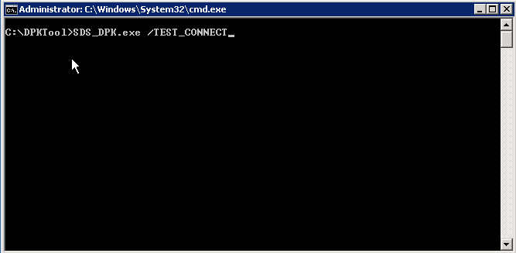
Database creation with DPK Import
- CSV containing the DPKs format must match the below format to be imported properly:
  - DellPartNumber;Facility; KeyId;Key; Vendor; CreatedDate;Allocated To
  - SDS_DPK.exe /INSTALL_TABLE /IMPORT:”c:\temp\dell_dpk.csv”

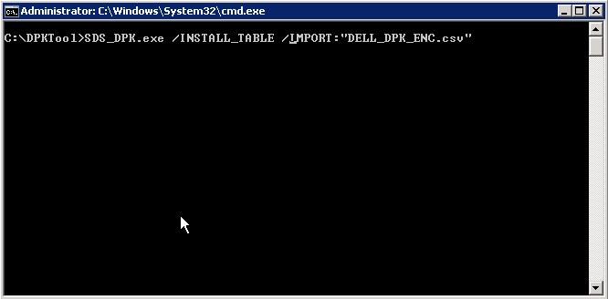
- The log file will be created next to the EXE with filename SDS_DPK.log.
  - The log contains connection information and flash status.
  - All info related to DPK/DPK_id is not included for security reasons.
    - To report must have DPK+PPID+STATUS=7
- Create the database, table and all the fields.
  - Setup SQL with TABLE+import CSV file (case sensitive)
  - Run Command to create database, table and fields and import first DPKs. Only use the create table command if the database has not been created previously.
    - C:\>SDS_DPK.exe /INSTALL_TABLE /IMPORT:”c:\temp\dell_dpk.csv”
    - Check the log to make sure there are no errors.
    - SDS_DPK.log Example after the command is run.
      - [20-05-2019 18:20:21.256] : -- SDS_DPK tool started --
      - [20-05-2019 18:20:21.256] : Arg(1): /INSTALL_TABLE
      - [20-05-2019 18:20:21.259] : Arg(2): /IMPORT:DELL_DPK_ENC.CSV
      - [20-05-2019 18:20:21.581] : '30' dpk enties added to database...
      - [20-05-2019 18:20:21.585] : -- SDS_DPK tool finished
  - Importing a new set of DPKs use this command. Use this command when the table has been created already.
    - C:\>SDS_DPK.exe /IMPORT:”c:\temp\dell_dpk.csv”
      - Where dell_dpk.csv is the name of the CSV file
    - Check the log to make sure there are no errors.
Notes:
- The SDS_DPK.exe /IMPORT:”DPK.csv” file command will only import DPKs that are associated to a dpk_id that is not already in the DPK database
- If the dpk_id is already present in the DPK database, the csv line is skipped and will not be imported
- If the DPK is invalid, it will be skipped and not imported
    - Always check the log to make sure there are no errors creating the table and importing the keys as a best practice.
      - Example of log if DPKs already exist:
[28-05-2019 12:30:43.743] : -- SDS_DPK tool started - 1.0.0.11 --
[28-05-2019 12:30:43.743] : Arg(1): /TEST_CONNECT
[28-05-2019 12:30:44.320] : -- SDS_DPK tool finished --
[28-05-2019 12:33:15.157] : -- SDS_DPK tool started - 1.0.0.11 --
[28-05-2019 12:33:15.157] : Arg(1): /INSTALL_TABLE
[28-05-2019 12:33:15.157] : Arg(2): IMPORT:DELL_DPK_ENC.csv
[28-05-2019 12:33:15.297] : -- SDS_DPK tool finished --
[28-05-2019 12:38:51.930] : -- SDS_DPK tool started - 1.0.0.11 --
[28-05-2019 12:38:51.930] : Arg(1): /IMPORT:DELL_DPK_ENC.csv
[28-05-2019 12:38:52.117] : '30' dpk enties added to database...
[28-05-2019 12:38:52.117] : -- SDS_DPK tool finished --
[28-05-2019 12:40:43.112] : -- SDS_DPK tool started - 1.0.0.11 --
[28-05-2019 12:40:43.112] : Arg(1): /IMPORT:DELL_DPK_ENC.csv
[28-05-2019 12:40:43.377] : DPK_ID '1801945624965' already present in database, skipping it...
[28-05-2019 12:40:43.392] : DPK_ID '1801945624966' already present in database, skipping it...
[28-05-2019 12:40:43.392] : DPK_ID '1801945624967' already present in database, skipping it...
[28-05-2019 12:40:43.392] : DPK_ID '1801945624968' already present in database, skipping it...
[28-05-2019 12:40:43.392] : DPK_ID '1801945624969' already present in database, skipping it...
[28-05-2019 12:40:43.392] : DPK_ID '1801945624970' already present in database, skipping it...
[28-05-2019 12:40:43.408] : DPK_ID '1801945624971' already present in database, skipping it...
[28-05-2019 12:40:43.408] : DPK_ID '1801945624972' already present in database, skipping it...
[28-05-2019 12:40:43.408] : DPK_ID '1801945624973' already present in database, skipping it...
[28-05-2019 12:40:43.408] : DPK_ID '1801945625091' already present in database, skipping it...
[28-05-2019 12:40:43.408] : DPK_ID '1801945625092' already present in database, skipping it...
[28-05-2019 12:40:43.424] : DPK_ID '1801945625093' already present in database, skipping it...
[28-05-2019 12:40:43.424] : DPK_ID '1801945625094' already present in database, skipping it...
[28-05-2019 12:40:43.424] : DPK_ID '1801945625095' already present in database, skipping it...
[28-05-2019 12:40:43.424] : DPK_ID '1801945625096' already present in database, skipping it...
[28-05-2019 12:40:43.424] : DPK_ID '1801945625097' already present in database, skipping it...
[28-05-2019 12:40:43.424] : DPK_ID '1801945625098' already present in database, skipping it...
[28-05-2019 12:40:43.439] : DPK_ID '1801945625099' already present in database, skipping it...
[28-05-2019 12:40:43.439] : DPK_ID '1801945625988' already present in database, skipping it...
[28-05-2019 12:40:43.439] : DPK_ID '1801945625989' already present in database, skipping it...
[28-05-2019 12:40:43.439] : DPK_ID '1801945625990' already present in database, skipping it...
[28-05-2019 12:40:43.439] : DPK_ID '1801945625991' already present in database, skipping it...
[28-05-2019 12:40:43.455] : DPK_ID '1801945625992' already present in database, skipping it...
[28-05-2019 12:40:43.455] : DPK_ID '1801945625993' already present in database, skipping it...
[28-05-2019 12:40:43.455] : DPK_ID '1801945625994' already present in database, skipping it...
[28-05-2019 12:40:43.455] : DPK_ID '1801945625995' already present in database, skipping it...
[28-05-2019 12:40:43.455] : DPK_ID '1801945625996' already present in database, skipping it...
[28-05-2019 12:40:43.470] : DPK_ID '1801945626132' already present in database, skipping it...
[28-05-2019 12:40:43.470] : DPK_ID '1801945626133' already present in database, skipping it...
[28-05-2019 12:40:43.470] : DPK_ID '1801945626134' already present in database, skipping it...
[28-05-2019 12:40:43.470] : '0' dpk enties added to database...
[28-05-2019 12:40:43.470] : -- SDS_DPK tool finished --

DPKDB Database backup and restore. Synchronizing ImportUser SID between servers

DPKDB Database backup and restore. Synchronizing the ImportUser user SID on 2 or more servers
____________________________________________________________________________________________
This section describes a process that provides a strategy to help transitioning from one SQL server with the same database to the other.

It will make sure the user account that is needed for database access is in sync on both servers.
It uses a SQL server backup on “Server 1” and SQL restore on “Server 2” process.
You should get feedback on this and any process from your IT department to make sure it meets your internal security requirements.
If needed you can add to the process to bring this method to your internal IT requirements.

In order for you to be able to backup and restore the DPKDB database from your production server to your backup / staging server, and have it be accessible by the ImportUser Account, you will need to follow the below instructions.
This process will show you how to create ImportUser accounts on both SQL servers that has the same SID or Security Identifier.
Without the same SID, the ImportUser will not have access to the database when restored to “Server 2”.

“Server 1” is the Database Backup from Server or originating server with the data you want to back up.
“Server 2” is the Database Restore to Server or the server you want to restore the data on.
Depending upon your backup strategy or server rotation process, these server roles could be reversed or rotated as needed.

Creating the ImportUser Account to match on both SQL servers.

On “Server 1” DPK SQL Server
- Open SQL Server Management Studio.
- Run below SQL query on the server

Use Master
GO
Select Name, SID
FROM sys.sql_logins
Where Name = 'ImportUser'

- To run the above Query on “Server 1”, perform the following steps.
- Click on New Query
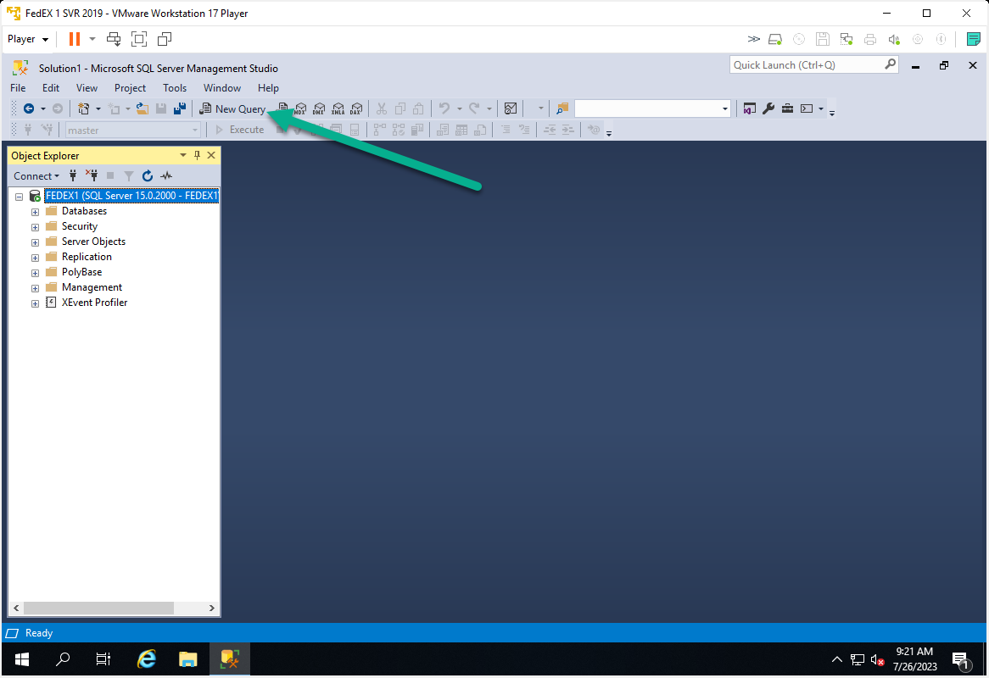

  - Paste the Query into the New Query screen.
Use Master
GO
Select Name, SID
FROM sys.sql_logins
Where Name = 'ImportUser'

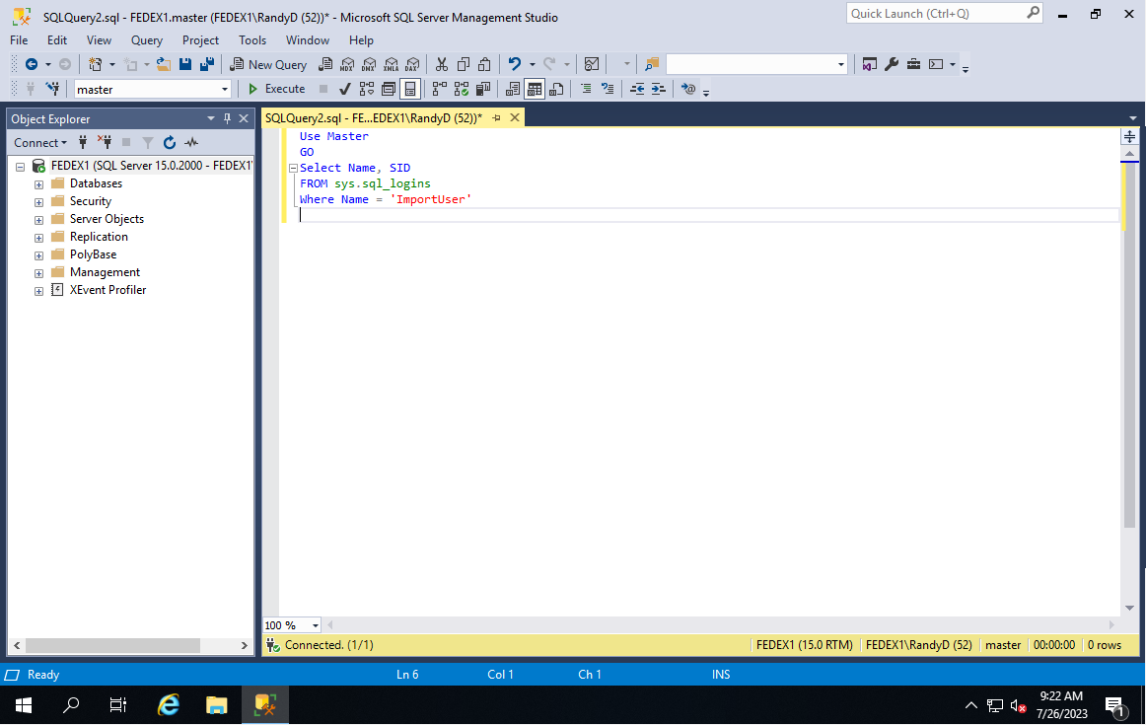

  - Click on the “Execute” button.
  - If you SQL Server Management Studio does not have an Execute button, you can right click on a blank part of the new query window and click on execute. Shown below.

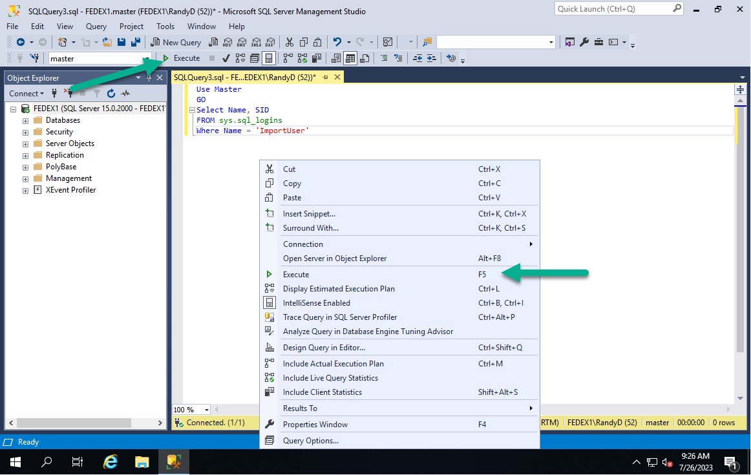

  - Copy the SID of the ImportUser for use when creating the account on the “Server 2”.
  - Highlight the SID and right click and click copy.

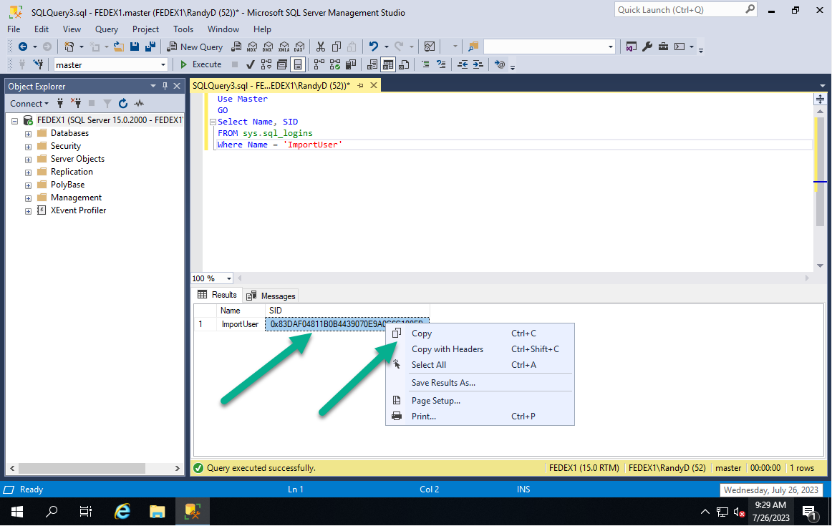

  - Save the ImportUser SID from “Server 1” so you can use it in the command to create the account on “Server 2”
  - You will only need to do this once, as the ImportUser account SID will not change after creation.

On the new SQL Server
- Open SQL Server Management Studio and connect to the local SQL server with Administrative rights.
- Click on New Query
- Paste the below query into the New Query screen.

Create Login [ImportUser] WITH PASSWORD = 'Import123!@#', SID = Your SID from the above Query on “Server 1”

Example from my test server, your SID will be different
Create Login [ImportUser] WITH PASSWORD = 'Import123!@#', SID = 0x83DAF04811B0B4439070E9A0C6C100FB

- Right Click on a blank space on the New Query screen and click on “Execute” or right click on a blank part of the new query window and click “Execute”.

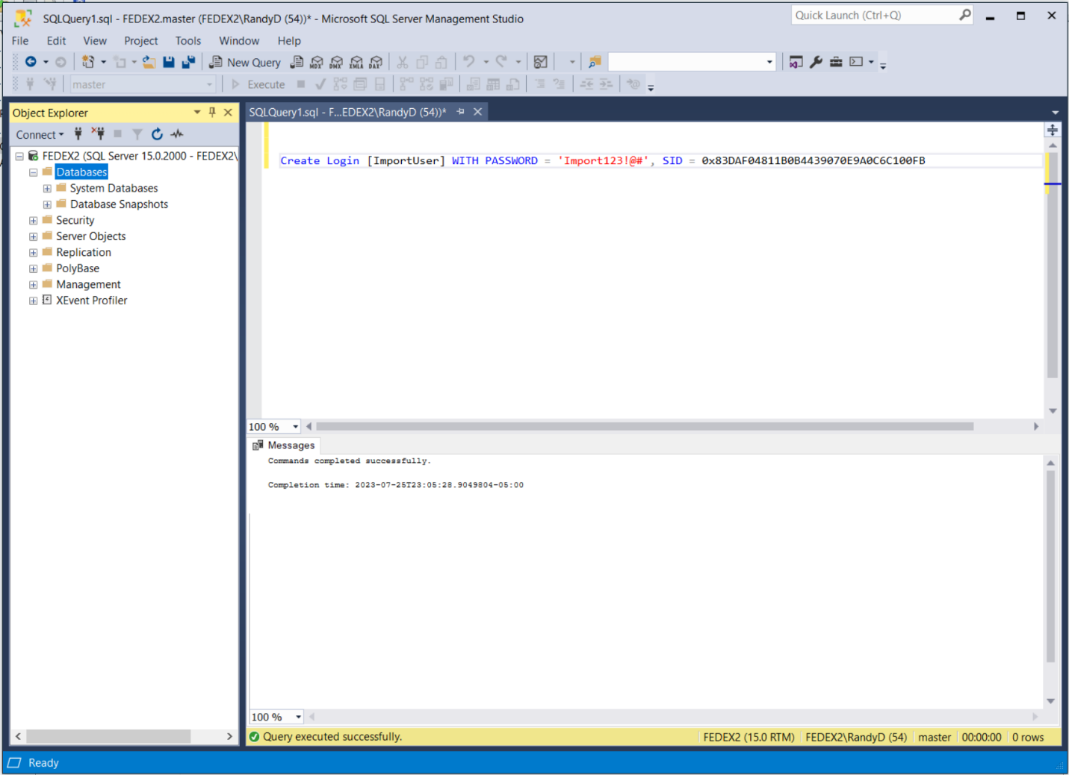

- The ImportUser account will be created on “Server 2” with the same SID as “Server 1”.
  - This allows the ImportUser to have the same access to the restored database DPKDB on “Server 2” as it did on “Server 1”
  - You will only need to use the above command to create the ImportUser account once on “Server 2” as the ImportUser account SID will not change after creation.
    - If for some reason the account is deleted or a new server has to be setup, you will need to run this command on the new server “Server 2” to create ImportUser with the proper SID.

- Complete the setup of the ImportUser on “Server 2” by verifying its setting.
- Go to Security à Logins à ImportUser and double click on it.
- Check to match up how you have your other ImportUser account setup on the other server or from the documentation. Uncheck Enforce password policy.

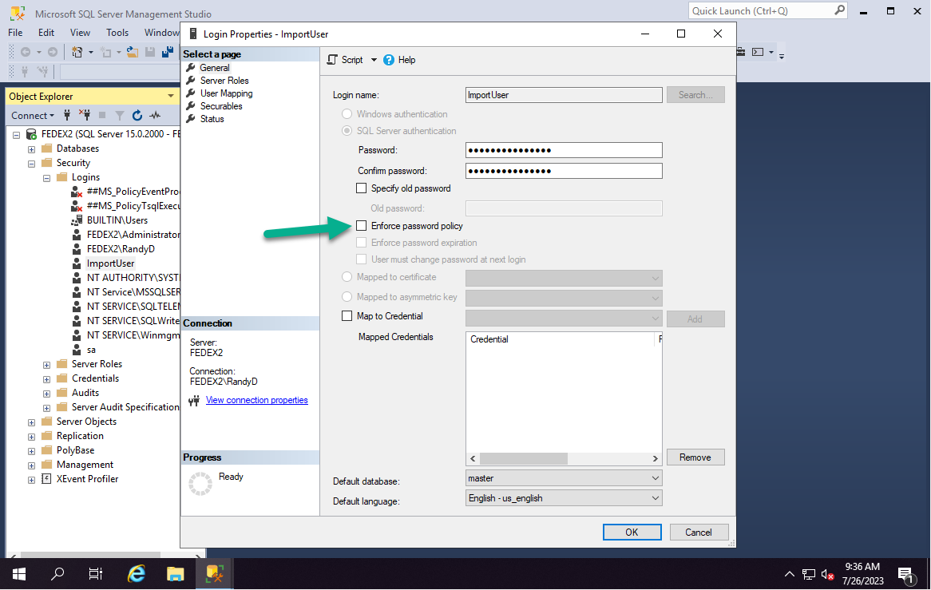

- Click on “Securables” and verify it has the needed permissions.
- Click on Grant for “Create any database”. Shown in the below image.
- Click “OK” to apply the changes.

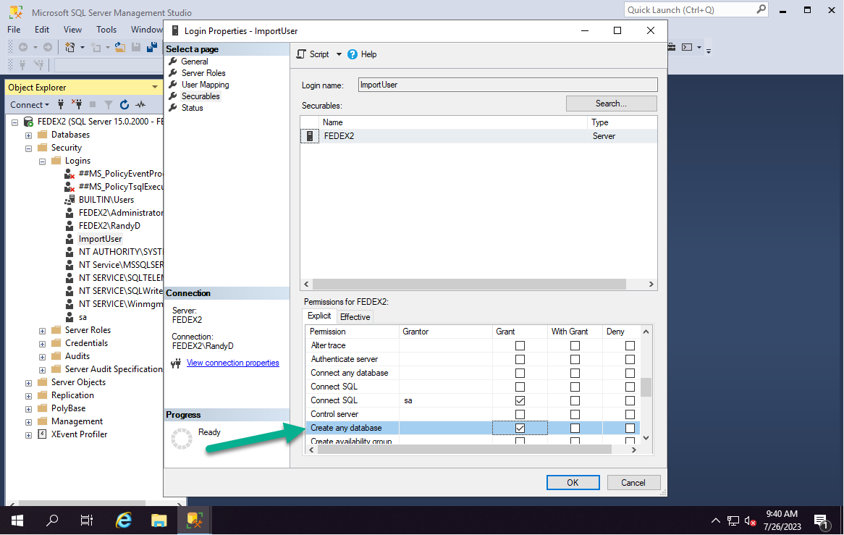

- Restore you DPKDB database to “Server 2”. Instructions on backing up the database on “Server 1” and restoring to “Server 2” is below.

- You can also test by using some SDS_DPK.exe /TEST_CONNECT to “Server 2” IP address.

In this example I use DPDDB_Backup_7-25-2023.bak as the database backup filename. Normally you would use the date and time stamp after the name to make sure you keep track of the latest on.
Depending on the frequency of backups you are performing.

Important Notes:
- Backup DBKDB on “Server 1”.
  - This process should be done while production is not running.
  - This will ensure that all DPK transaction performed are completed before the backup is created.
  - Otherwise, you will not have all transaction that occurred after the backup was created in the backup file.

Backup DPKDB database using SQL Server Management Studio.
- Open SQL Server Management Studio
- Connect to and Login as an administrator of the Local SQL server.
- Expand the Databases section.
- Right click on the DPKDB database and click on Tasks and the Back Up.

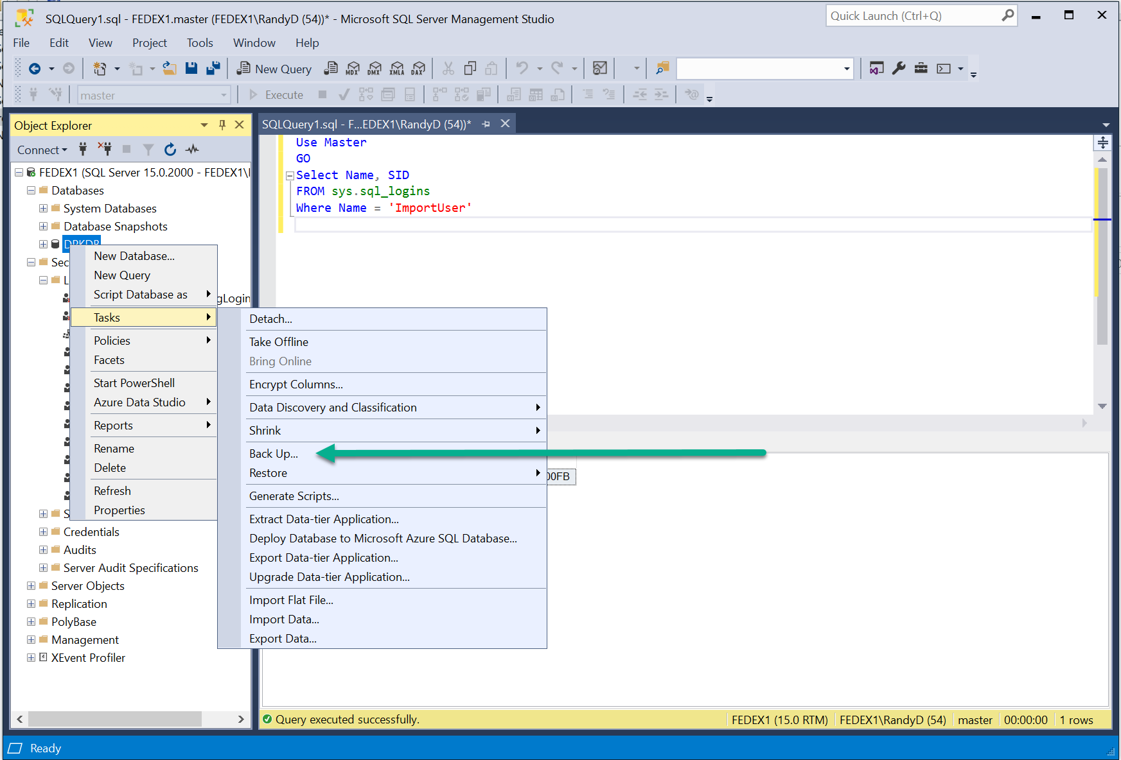

- The below screen will appear.
- Verify the following:
  - Database is “DPKDB”
  - The Backup type is “Full”
  - Back up to is “Disk”
  - The default backup location should be in your installation directory.
  - If you would like it to be backed up to another location you can click on the remove button as shown below.
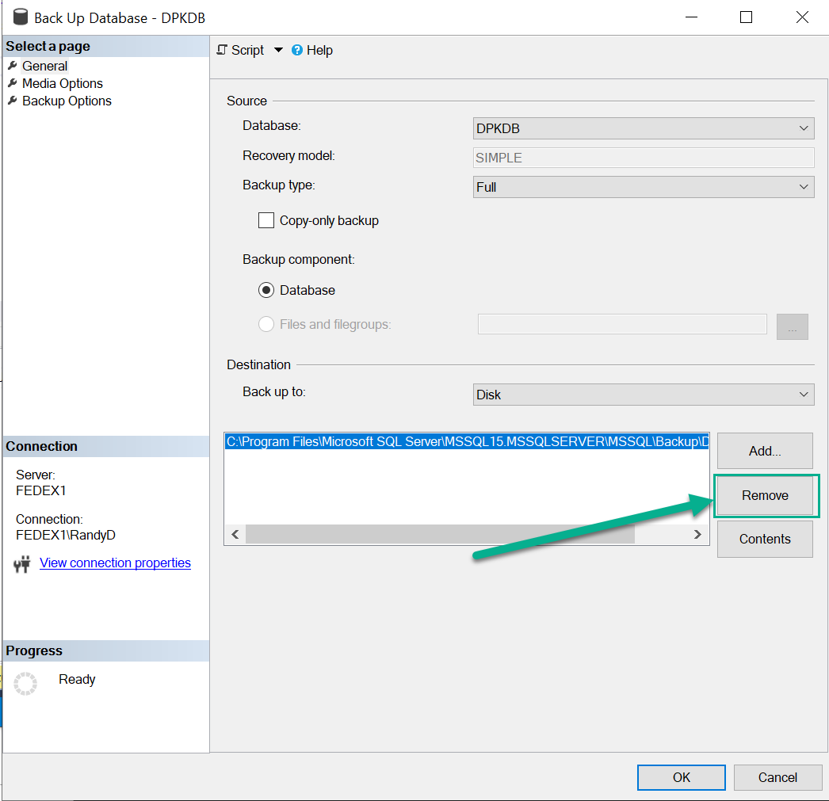

- Click on Add and the below box will appear. Click on the below button to browse to the location you would like to backup the DPKDB database to.

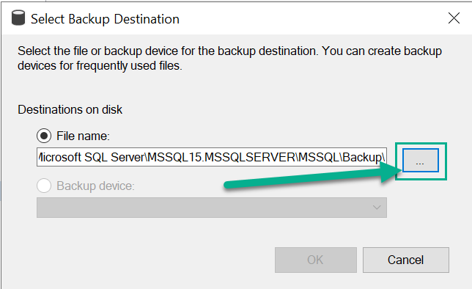

- Browse to the directory you want to backup to and type in the name of the file you want to use.

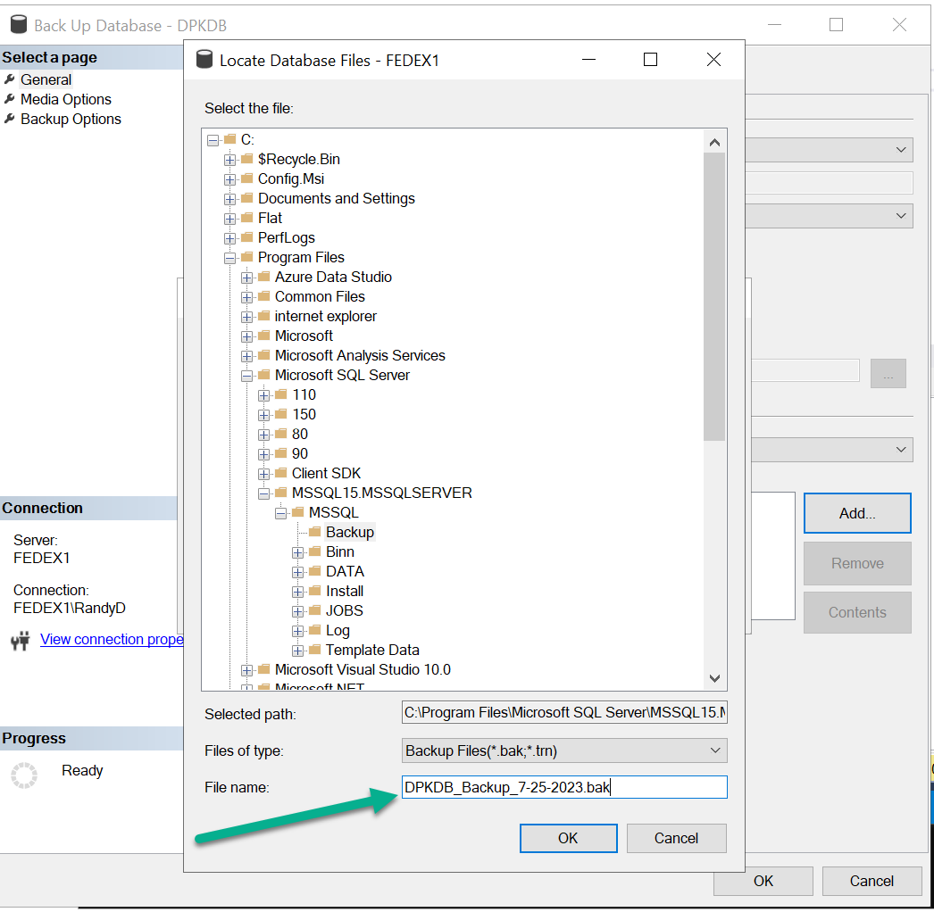

- Click on the “OK” button

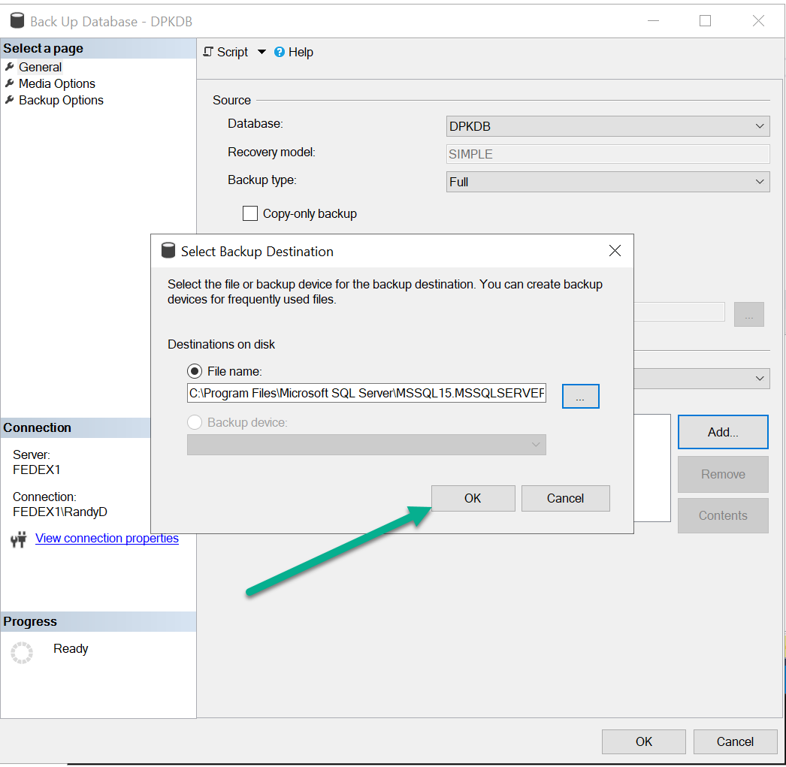

- Verify the information is correct and click on “OK” again.

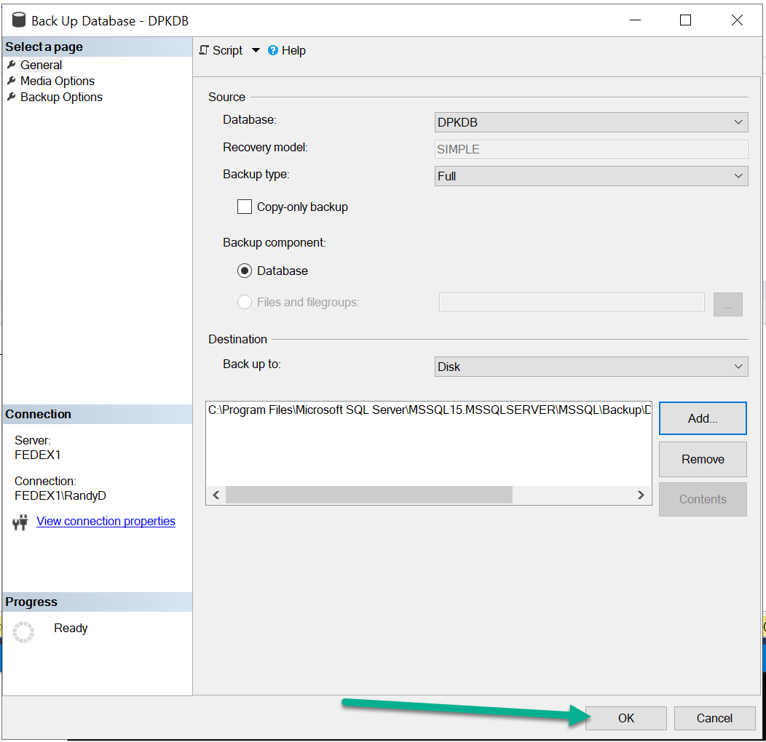

- The back up process will display a dialogue box showing the back up was successful.

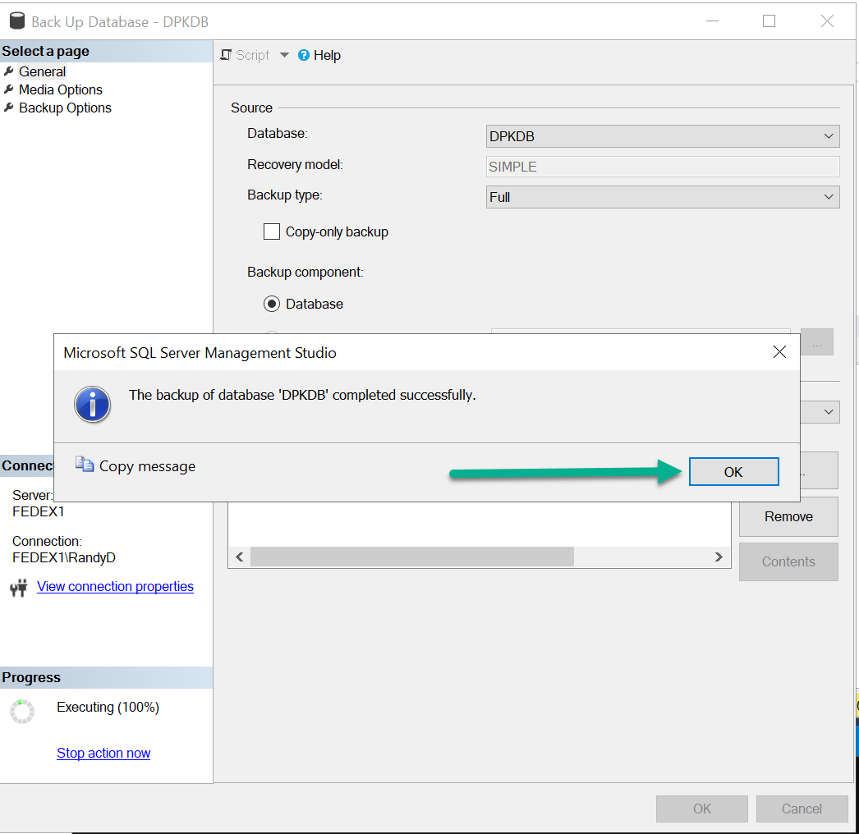

- Click on “OK: and the screen will disappear.
- Now you can browse to the directory and copy that backup file to “Server 2” to be restored.

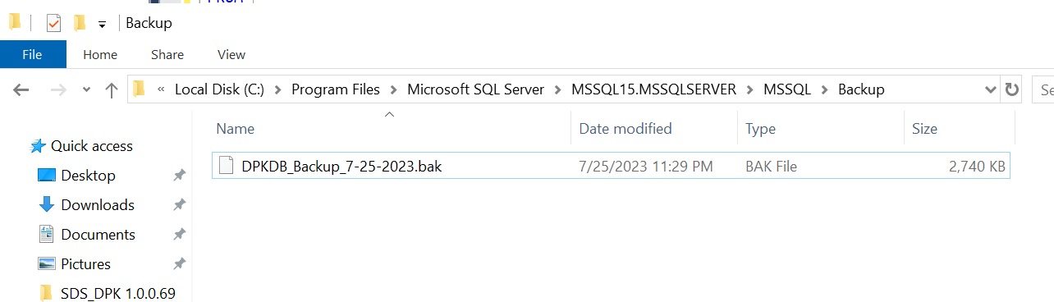

- Copy the DPKDB backup file to “Server 2”.

Restoring DPKDB to “Server 2”.
This new server will not have the DPKDB database on it at this state since you are first setting it up.
- Important Note:
  - Restoring DPKDB backup to “Server 2” – if you already have a DPKDB database on “Server 2”.
  - Before restoring the DPKDB backup created on “Server 1” to “Server 2”, you will need to make sure the DPKDB does not exist on “Server 2” or you will get an error during the restore process.
  - If needed or if there is any test data on the “Server 2” DPKDB that you need, back up the “Server 2” DPKDB first.
    - The backup file should be a filename that is easily identifiable with date and time stamp as well as a short description of what it is.
  - Once the backup is created, then remove or drop the DPKDB database from “Server 2”.
  - You can then restore the production DPKDB to “Server 2” without any errors.
- After copying and pasting the DPKDB_Backup_7-25-2023.bak to your new server.
  - This file name should follow your internal naming and tracking convention to make sure you can identify the Database_Date_Time and a short description to help you identify it easily.
- Open SQL Server Management Studio and login to the SQL Server for “Server 2”.
- Right click on Databases and select Restore Database

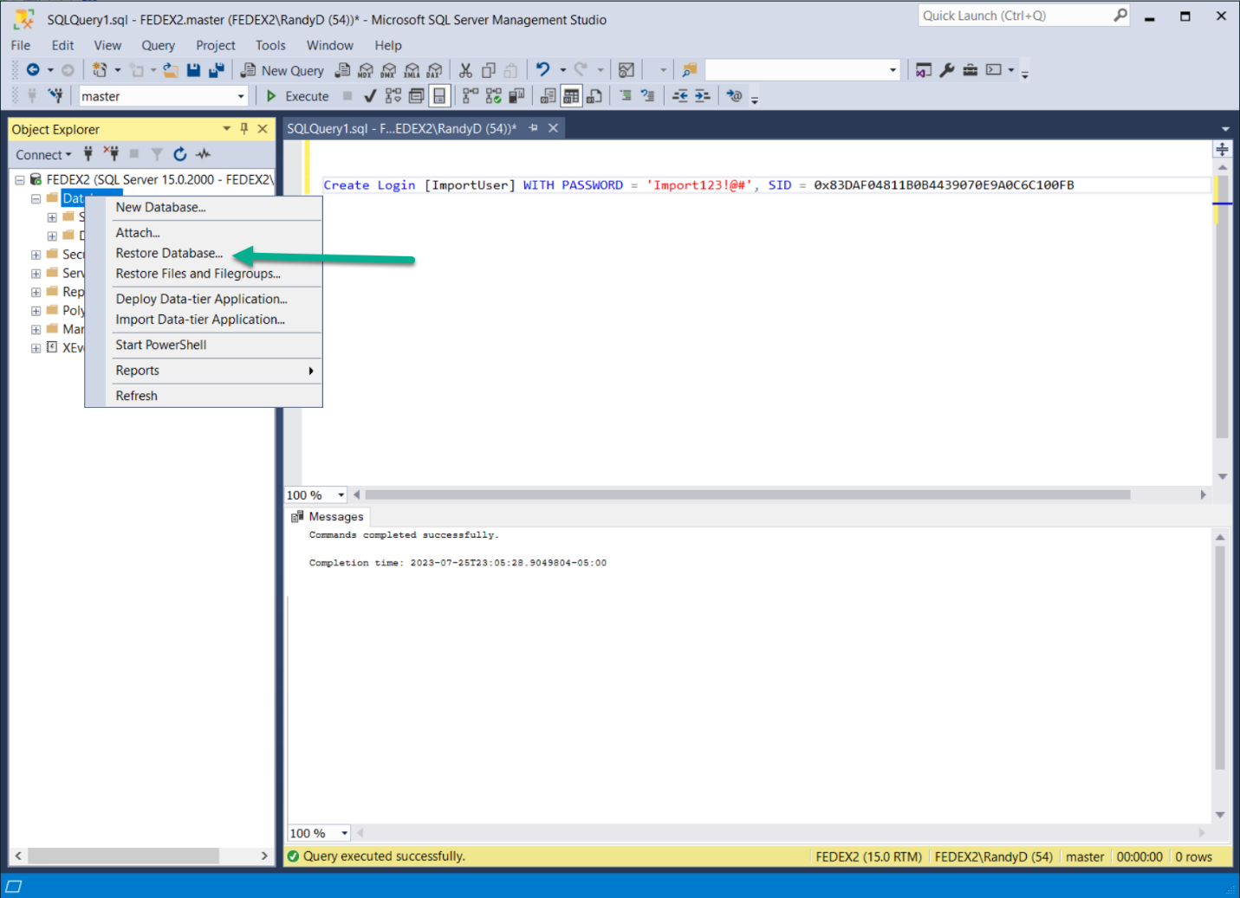

- Under General à Source
- Click on “Device”
- Click on the box to the right of Device as shown below.

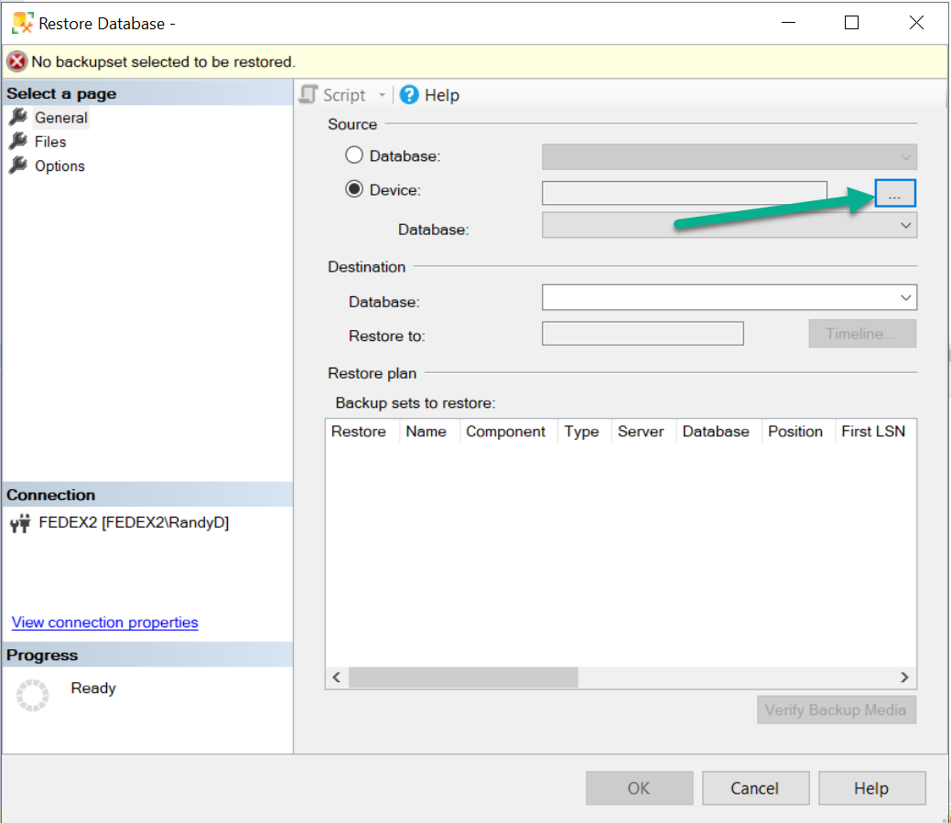

- For Backup media type it should say “File”
- Click on the Add button.

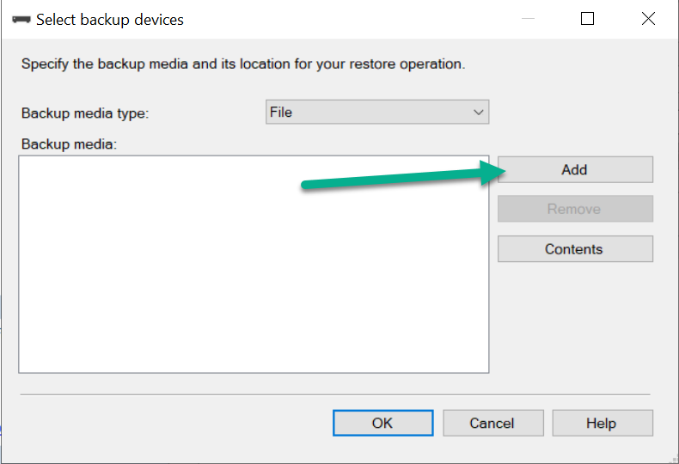

- Browse to where you copied the DPDDB_Backup_7-25-2023.bak file to.
- Highlight the file as shown below and click on “OK”

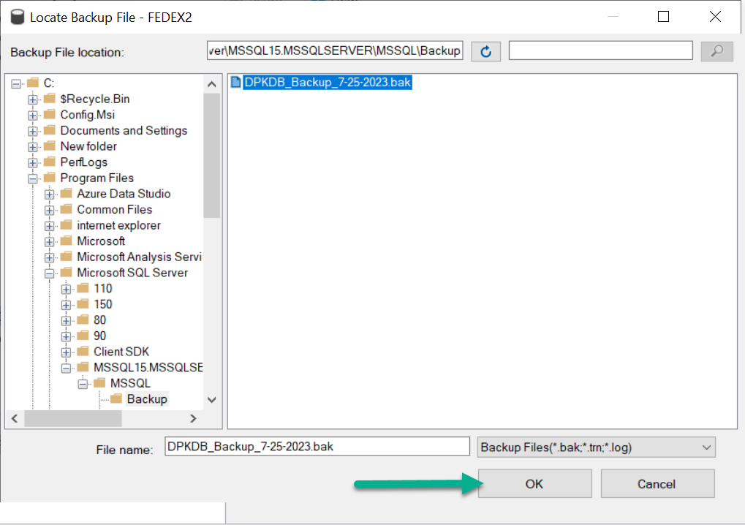

- Verify the path and filename is the correct one and then click on “OK” again.

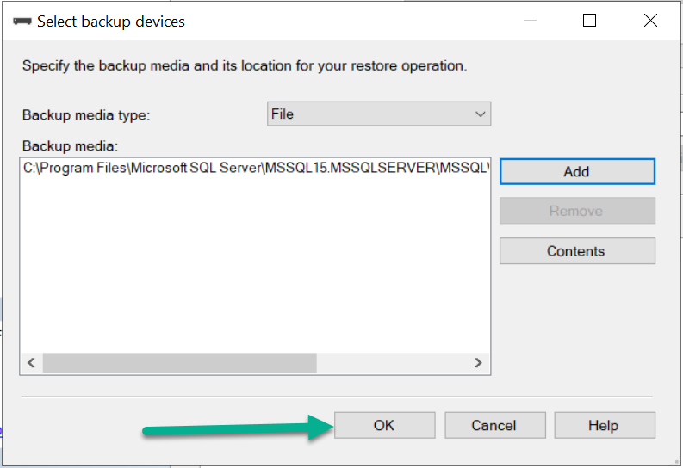

- Finally on the last page verify the information is correct and then click on “OK”.

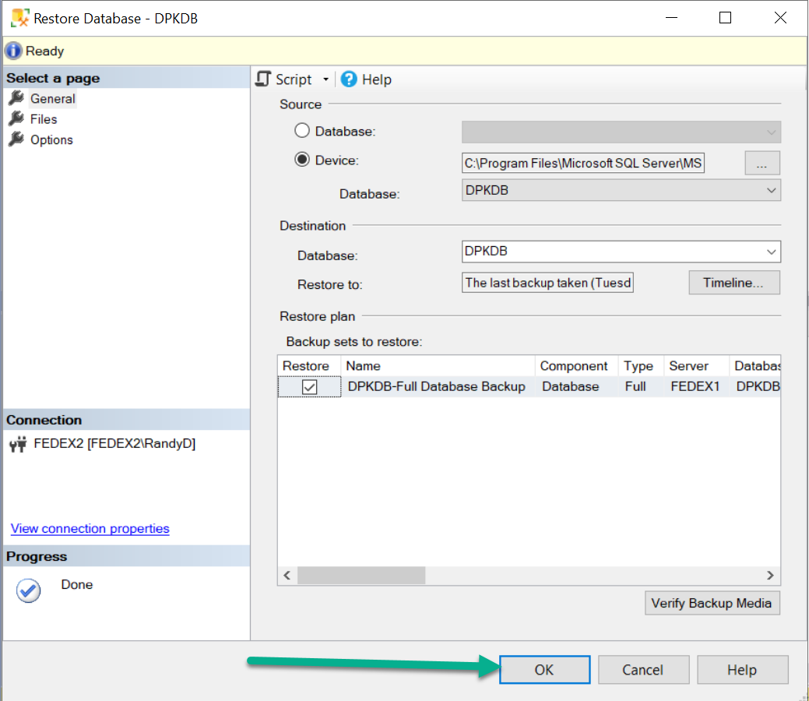

- You will receive a message if the restore is successful.

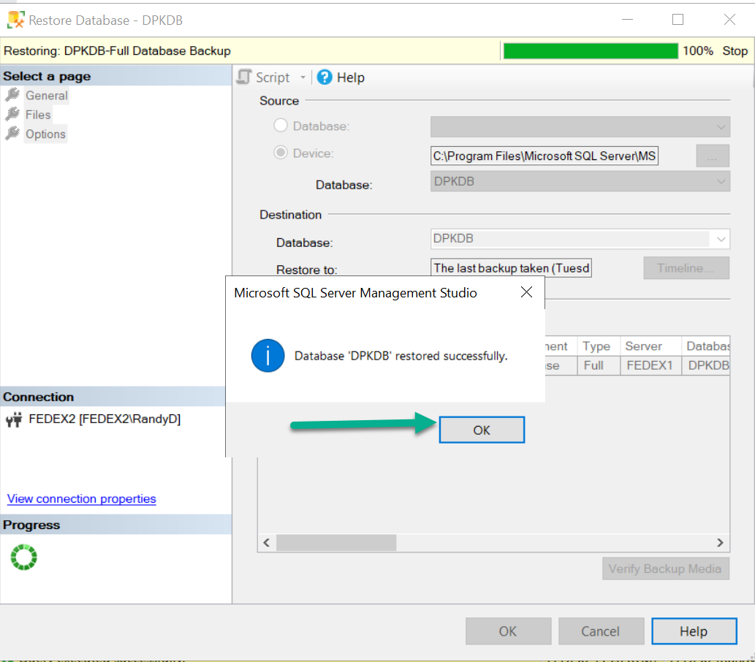

- Click on “OK”, the restore is complete and this server is ready to test to make sure you can access the database using the same ImportUser SQL Account
- You can also test by using the command SDS_DPK.exe /TEST_CONNECT to “Server 2” IP address.

SMBIOS used to determine which IBV tool to use to inject DPK.
Use the SMBIOS OEM string (type 11) tag 14 to determine which IBV tool should be used to flash DPK.
wmic computersystem get OEMStringArray

BIOS vendor as shown in SMBIOS | Tool to use
14[0] or 14[1] in SMBIOS | IBVFlash_V1_10 (version), use IBVFlashx32.exe or IBVFlashx64.exe as appropriate for the architecture
14[2] in SMBIOS | InsydeOAv1.0.0.1 (version), use InsydeOA32.exe or InsydeOA64.exe as appropriate for the architecture
14[3] in SMBIOS | 0320OA3Tool (version), use the Flash.exe from the appropriate architecture folder

0 = AMI 1 = Dell 2 = Insyde 3 = Phoenix 4 = Inventec

Script Integration-Stand Alone Instructions
Remove clearing the DPK from all start up and test scripts.
If you are running the test script from a USB key, ensure that the dpkppid.txt is deleted from c:\Oa30\DPK as well as the SDS_DPK.log from c:\Oa30\DPK.
Add a Robocopy command to the startup.bat to copy down the DPK Utility from the mapped network drive.
Add the Command to run the utility, copy logs, and clean up after to the Test script after all functional tests have completed.

The best method would be to set an environment variable for the mapped drive as this example below and change all hard-coded mapped drive to the variable.

**IMPORTANT: Only run mfgmode64w +SMMM > mfgmode.txt after all DPK Injection & Verification Process has completed. Doing this in conjunction with ServiceReset will clear the DPK!!
Order is as follows:
Service Reset
Inject DPK
Reboot
Verify DPK
Set Service Menu
Shutdown Right after setting the service menu

------------------------------------------------------------------------------------------------------------------------------------

StartUp Example and Test Execution Examples
-------------------------------------------------------------------------------------------------------

Script Integration Example
Remove clearing the DPK from all start up and test scripts.
Add a Robocopy command to the startup.bat to copy down the DPK Utility from the mapped network drive.
Add the Command to run the utility, copy logs, and clean up after to the Test script after all functional tests have completed.

Embedded are examples only. In this example the mapped drive is X. Some Test Scripts may be hardcoded to map as P, X, or Z.
The best method would be to set an environment variable for the mapped drive as this example below and change all hard-coded mapped drive to the variable.
Also, since IP Addresses can be different, it would be better to set an environment variable for that IP Address in the startup.bat as well.

**IMPORTANT: Only run mfgmode64w +SMMM > mfgmode.txt after all DPK Injection & Verification Process has completed. Doing this in conjunction with ServiceReset will clear the DPK!! See the service_reset.bat embedded
Order is as follows:
Service Reset
Inject DPK
Reboot
Verify DPK
Set Service Menu
Shutdown Right after setting the service menu

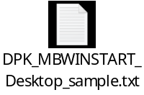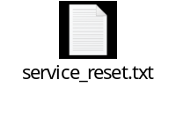

Using SDS_DPK_x64.exe in WINPE only

If running in Winpe, we need the following Optional Components added to the WinPE to run.
According to Microsoft, there is strict package order that must be used, otherwise you will get incomplete feature installed.
https://docs.microsoft.com/en-us/windows-hardware/manufacture/desktop/winpe-add-packages--optional-components-reference

The package list from the Dell Winpe had the scripting package installed on their WinPE at the very beginning and SecurebootCmdlet does not respect the package dependencies order.

Use the following dism command to list packages:
dism /Mount-Wim /WimFile:D:]Wim\boot.wim /Index:1 /MountDir:D:\Mount1
then
dism /image:d:\mount1 /get-packages
to list the packages in the wim and check the order. (see example below)

- Dependencies: Install WinPE-WMI > WinPE-NetFX > WinPE-Scripting > WinPE-PowerShell

Package Identity : WinPE-WinReCfg-Package~31bf3856ad364e35~amd64~~10.0.18362.1
Install Time : 6/4/2019 2:50 PM
Package Identity : WinPE-WMI-Package~31bf3856ad364e35~amd64~~10.0.18362.1
Install Time : 6/4/2019 2:50 PM
Package Identity : WinPE-MDAC-Package~31bf3856ad364e35~amd64~~10.0.18362.1
Install Time : 6/4/2019 2:50 PM
Package Identity : WinPE-Scripting-Package~31bf3856ad364e35~amd64~~10.0.18362.1
Install Time : 6/4/2019 2:50 PM

Package Identity : WinPE-SecureStartup-Package~31bf3856ad364e35~amd64~~10.0.18362.1
Install Time : 6/4/2019 2:51 PM
Package Identity : WinPE-EnhancedStorage-Package~31bf3856ad364e35~amd64~~10.0.18362.1
Install Time : 6/4/2019 2:51 PM
Package Identity : WinPE-HTA-Package~31bf3856ad364e35~amd64~~10.0.18362.1
Install Time : 6/4/2019 2:51 PM

Package Identity : WinPE-NetFx-Package~31bf3856ad364e35~amd64~~10.0.18362.1
Install Time : 6/4/2019 2:53 PM
Package Identity : WinPE-PowerShell-Package~31bf3856ad364e35~amd64~~10.0.18362.1
Install Time : 6/4/2019 2:53 PM

Package Identity : WinPE-SecureBootCmdlets-Package~31bf3856ad364e35~amd64~~10.0.18362.1
Install Time : 6/4/2019 2:54 PM
Package Identity : WinPE-StorageWMI-Package~31bf3856ad364e35~amd64~~10.0.18362.1
Install Time : 6/4/2019 2:54 PM
Package Identity : Microsoft-Windows-WinPE-Package~31bf3856ad364e35~amd64~~10.0.18362.113
Install Time : 5/15/2019 5:45 PM
Package Identity : Package_for_RollupFix~31bf3856ad364e35~amd64~~18362.113.1.4
Install Time : 5/15/2019 5:45 PM
Package Identity : WinPE-DismCmdlets-Package~31bf3856ad364e35~amd64~~10.0.18362.1
Install Time : 6/4/2019 2:54 PM

So if needed, please reorder the package installation to the order below.
<package>WinPE-WMI.cab</package>
<package>WinPE-NetFX.cab</package>
<package>WinPE-Scripting.cab</package>
<package>WinPE-DismCmdlets.cab</package>
<package>WinPE-SecureBootCmdlets.cab</package>
<package>WinPE-StorageWMI.cab</package>
<package>WinPE-SecureStartup.cab</package>
<package>WinPE-PPPoE.cab</package>
<package>WinPE-HTA.cab</package>
<package>WinPE-MDAC.cab</package>

If running 64bit Winpe use the following logic to run the correct version of the tool if needed, else just call the correct version of the tool for your Winpe architecture.
In Windows, you can always use the 32 bit version, no need for any detection. (SDS_DPK.exe)

@echo off
echo Detecting OS processor type

if "%PROCESSOR_ARCHITECTURE%"=="AMD64" goto 64BIT
echo 32-bit OS
sds_dpk……
goto END
:64BIT
echo 64-bit OS
sds_dpk_X64
:END

